Introduction

Lesson Objectives
Upon completion of this lesson the student will be able to:
- Explain the WCDMA evolution path
- Describe the difference between the TDMA, CDMA and WCDMA coding techniques
- Describe the main functions of WCDMA RAN
- Provide an overview of the air interface in WCDMA

Introduction
WCDMA (Wideband Code Division Multiple Access) is the world’s leading 3G technology. It introduces a new generation of telecommunication into the world and changes the way people communicate forever providing mobile users with data rates up to 2 Mbps. WCDMA is an ultra high-speed, ultra high-capacity radio technology that generates and carries a new range of rich, fast, colorful media that consumers will be able to access over their mobiles: color graphics, video, animations, digital audio, Internet and e-mail.
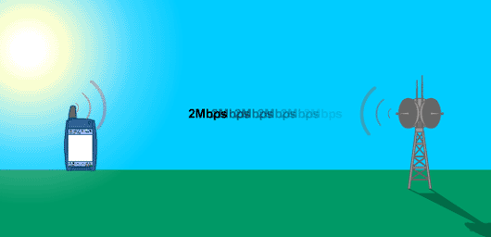

Introduction

Background
There has been a tremendous growth in wireless communication technology over the past decade. The significant increase in subscribers and traffic, new bandwidth consuming applications such as gaming, music down loading and video streaming places new demands on capacity. The answer to the capacity demand is the provision of new spectrum and the development of the new technology, the WCDMA.
WCDMA was developed in order to create a global standard for real time multimedia services that ensured international roaming. With the support of ITU (International Telecommunication Union) a specific spectrum was allocated – 2GHz for 3G telecom systems. The work was later taken over by the 3GPP (3rd Generation Partnership Project), which is now the WCDMA specification body with delegates from all over the world. Ericsson has for a long time played a very active role in both ITU and 3GPP and is a major contributor to WCDMA and the fulfillment of the vision of a global mobile telecommunication system.

3rd Generation Partnership Project (3GPP)
The main standardization effort for 3rd generation systems is handled in the 3rd generation partnership project (3GPP). 3GPP is a collaboration between regional standardization bodies as follows:
- European Telecommunications Standards Institute (ETSI)
- Wireless/Mobile Services and Systems technical subcommittee of the USA’s Committee T1 (T1P1)
- Telecommunication Technology Committee, Japan (TTC)
- Association of Radio Industries and Businesses, Japan (ARIB)
- Telecommunications Technology Association, Korea (TTA)
- China Wireless Telecommunication Standard group (CWTS)
In 2000, the standardization of GSM was moved from the European Telecommunications Standards Institute (ETSI) to the Third-generation Partnership Project (3GPP) to ensure the integrity of the GSM/WCDMA platform, thereby eliminating risks for incompatibility and inefficiency that might have occurred had the standardization been carried out by separate groups. 3GPP is organized in Technical Specifications Group (TSG) as shown in the figure below:
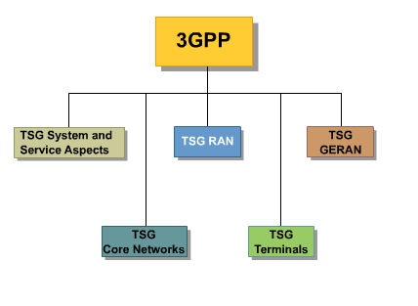
A fifth technical specifications group (TSG) called the GSM/EDGE Radio Access Network (GERAN) has been added to 3GPP to accommodate this work (Figure above). The main objective of the GERAN TSG is to align GSM/EDGE and WCDMA services, mainly as relates to providing conversational and streaming service classes. Best-effort and interactive service classes will also be supported.
These efforts will result in a GERAN system architecture that employs a common core network for WCDMA RAN and GERAN.

Introduction

WCDMA Evolution Path
WCDMA is a development from GSM and CDMA. The network structure is based on GSM and the air interface on CDMA.
The GSM network shown in the figure below consists of the Core network and the Radio Access Network. The end users are offered voice and low data transmission services. The network provides the Control logic to setup, maintain and release connections and the Connectivity capabilities that is the establishment of through connections between the end user and the requested service. The nodes are interconnected using mainly TDM techniques.
The traditional GSM network has been monolithic. The Monolithic Network Architecture provides Network Control and Connectivity in a monolithic implementation, that is, without any layering. This implies that Network Control and Connectivity are tightly coupled and located in one physical node.
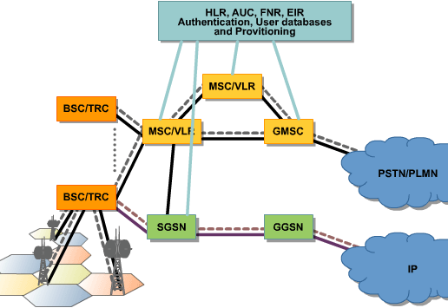

Introduction

WCDMA Evolution Path
The WCDMA consists of the Core Network, the Radio Access Network and the Service Network. The backbone is ATM based but IP is also possible.
The WCDMA network is a layered network consisting of three layers:
- Connectivity layer consisting of MGWs (The Ericsson M-MGW is named MGW throughout the WBL) and nodes to realize the mobile packet backbone network
- Control Layer containing the logic to setup, maintain and terminate call or service connections
- Service Layer containing all services the end user might have access to.
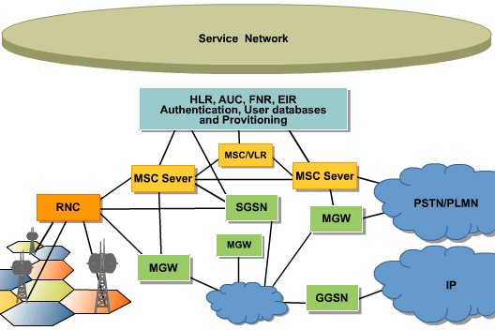
Evolving from the monolithic GSM the WCDMA network architecture follows the concept of layered network, according to 3GPP standards. The separation into different network layers is visible on logical level, where new logical nodes and new interfaces are introduced, as well as on physical implementation where the logical node are being implemented on different physical nodes/platforms, for example, MSC Server and MGW.

Introduction

WCDMA Evolution Path
GSM is used for second- and third-generation services since it evolves with EDGE technology, and the existing core network evolves into a layered architecture that supports GSM and WCDMA.
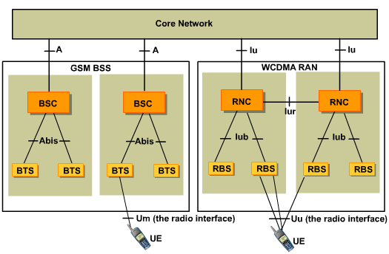

Introduction

WCDMA Evolution Path
The GSM Base Station Subsystem (BSS) and the WCDMA Radio Access Network (RAN) are both connected to the GSM core network for providing a radio connection to the UE. Hence, the technologies can share the same core network.
Furthermore, both GSM BSS and WCDMA RAN systems are based on the principles of a cellular radio system. The GSM Base Station Controller (BSC) corresponds to the WCDMA Radio Network Controller (RNC). The GSM Radio Base Station (RBS) corresponds to the WCDMA RBS, and the A-interface of GSM was the basis of the development of the Iu-interface of WCDMA, which mainly differs in the inclusion of the new services offered by WCDMA.
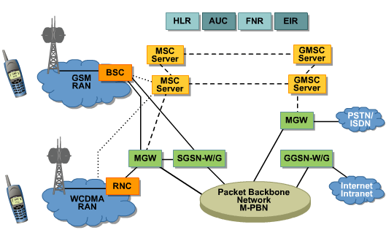
The significant differences, apart from the lack of interface between the GSM BSCs and an insufficiently specified GSM Abis-interface to provide multi-vendor operability, are more of a systemic matter. The GSM system uses TDMA (Time Division Multiple Access) technology with a lot of radio functionality based on managing the timeslots. The WCDMA system on the other hand uses CDMA (Code Division Multiple Access) which means that both the hardware and the control functions are different. Examples of WCDMA-specific functions are fast power control and soft handover.

Introduction

Lesson Objectives
Upon completion of this lesson the student will be able to:
- Describe the following WCDMA Subnetworks (Domains)
  - Circuit Switched domain
  - Packet Switched domain
- User Databases and other common nodes
- Describe the WCDMA RAN functionality and nodes
- Explain the Transport solution for the Core and RAN Networks
- Describe the WCDMA network management function and tools
- Describe the security issues in WCDMA

WCDMA Sub-Networks
The network reference model for WCDMA is shown above. Several Domains (sub-networks) and interfaces are defined utilizing the offered functions. The interfaces are shown in the sub-networks, which are discussed further on.
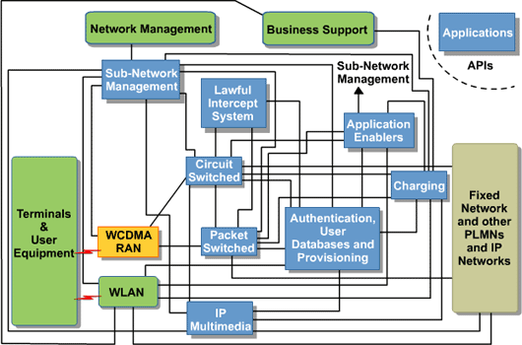

WCDMA Sub-Networks

CORE NETWORK CIRCUIT-SWITCHED DOMAIN

Introduction
Core Network Circuit-Switched domain (CNCS) comprises the core nodes and functionality related to circuit-switched speech and data calls within WCDMA mobile networks. Both monolithic and layered architecture are supported in current releases of WCDMA. The Core Network Circuit-Switched domain consists of following nodes:
- Media Gateway (MGW)
- Mobile Switching Center (MSC)
- Transit Switching Center (TSC)
- Signaling Transfer Point (STP)
- Operation Support System (OSS-RC)
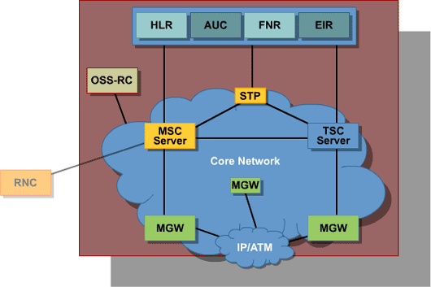

WCDMA Sub-Networks

CORE NETWORK CIRCUIT-SWITCHED DOMAIN

MGW
Media Gateway is responsible for connectivity when layered architecture is used.
The MGW handles payload processing, traffic and signaling interworking between networks.
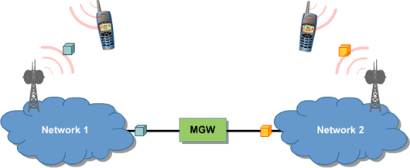

WCDMA Sub-Networks

CORE NETWORK CIRCUIT-SWITCHED DOMAIN
The user traffic function generates a trough connection path by bridging the termination points of the interconnected nodes.
The signaling interworking is handled by the Signaling Gateway Function that is integrated in the MGW.
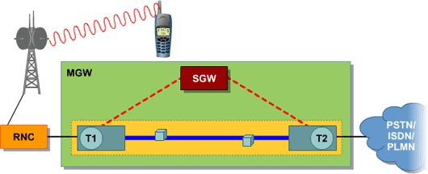

WCDMA Sub-Networks

CORE NETWORK CIRCUIT-SWITCHED DOMAIN
The MGW contains codecs and echo cancellers in order to process the payload and make the originating and terminating sides compatible. It contains also announcement devices, tone generating devices and call conference devices used to send announcements to the end users, tones to interconnected nodes and interconnect the users in a call conferences when needed. The figure here shows the media processing and the through connection.
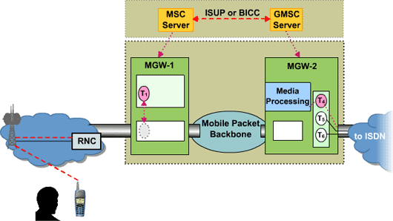
The WCDMA adapted User Equipment (UE) are using AMR coding in speech connections.

WCDMA Sub-Networks

CORE NETWORK CIRCUIT-SWITCHED DOMAIN
Ericsson’s MGW is an application based on a platform called Connectivity Packet Platform, CPP. The CPP platform uses a multi-processor control system built on commercial processors and real time operating system with telecom and robustness additions. The internal transport system uses subracks and is suitable for ATM, STM and IP networks solutions. All these CPP features are inherited to the MGW application.
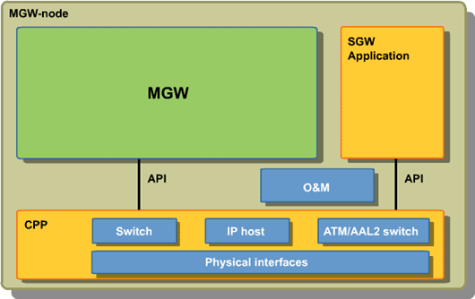

WCDMA Sub-Networks

CORE NETWORK CIRCUIT-SWITCHED DOMAIN

MSC
MSC is responsible for:
- setting up
- routing
- controlling
- terminating
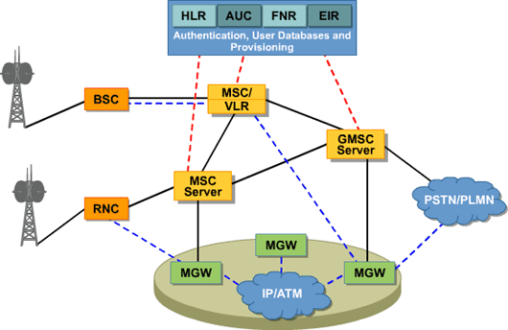
It also manages the collection of information for charging and accounting and handles the requests for Supplementary Services.

WCDMA Sub-Networks

CORE NETWORK CIRCUIT-SWITCHED DOMAIN
The MSC (Server or combined) contains the logic to perform inter and intra-MSC handovers.
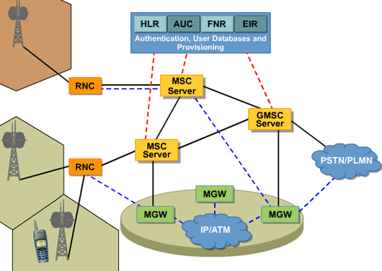

WCDMA Sub-Networks

CORE NETWORK CIRCUIT-SWITCHED DOMAIN
MSC is available in various configurations adapted to the operators needs.
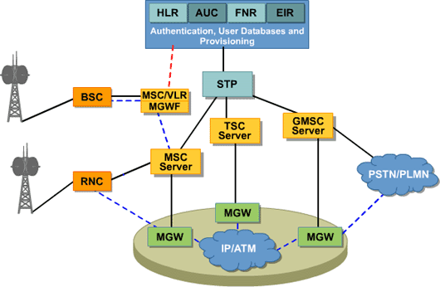
The MSC/VLR is a configuration of MSC that handles call control and user plane for circuit-based services. It includes the following logical nodes:
- MSC/MGW. This is combined node including a MSC Server function and a MGW function
- MSC Server
- Other options that may be included are HLR (including AUC and FNR as options)
- GMSC that is an MSC capable to interwork with external networks.
- Transit Switching Centre, TSC
- Signaling Transfer Point, STP

WCDMA Sub-Networks

CORE NETWORK CIRCUIT-SWITCHED DOMAIN

OSS-RC
OSS-RC is Ericsson’s sub-network manager, supporting centralized operation and maintenance of the radio access as well as the core networks of both GSM and WCDMA systems. OSS-RC is a solid step toward a completely integrated OSS-RC solution to support the Core Network and Radio Access Network for both the GSM & WCDMA Standards.
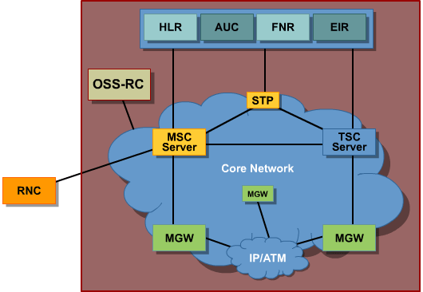

WCDMA Sub-Networks

CORE NETWORK CIRCUIT-SWITCHED DOMAIN

CS Domain Architecture
Core Network Circuit Switched domain, CNCS, as a part of WCDMA/GSM system, is schematically shown in the following figure:
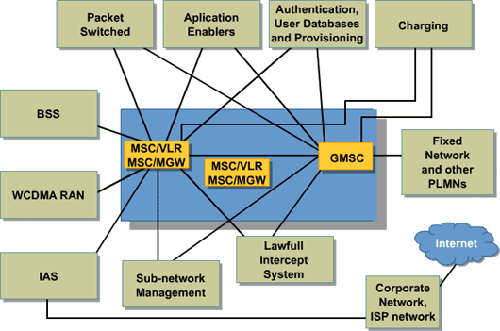
The Monolithic Network Architecture provides Network Control and Connectivity in a monolithic implementation, that is, without any layering. This implies that Network Control and Connectivity are tightly coupled and located in one physical node. Both WCDMA access, based on ATM transmission technology, as well as traditional GSM access, based on TDM transmission, are implemented. The figure above shows logical relations between nodes within CNCS and towards other part of the CN.

WCDMA Sub-Networks

CORE NETWORK CIRCUIT-SWITCHED DOMAIN
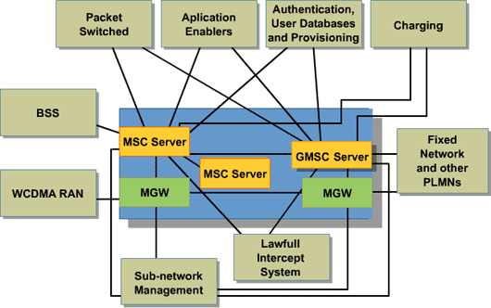
The split CNCS domain architecture follows the concept of layered network architecture, according to 3GPP standards, where the core network is divided into the two following different network layers:
- Network Control Layer
- Connectivity Layer
This separation is visible on logical level, where new logical nodes and new interfaces are introduced, as well as on physical implementation where the logical node are being implemented on different physical nodes/platforms, for example, MSC Server and MGW. WCDMA mobile access and CN are mainly using ATM transmission technology but IP is also possible.

WCDMA Sub-Networks

CORE NETWORK PACKET-SWITCHED DOMAIN

Introduction
Core Network Packet-Switched (CNPS) comprises the core nodes and functionality related to packet-switched data calls within WCDMA mobile networks.
The following nodes are in the scope of CNPS:
- Serving GPRS Support Node (SGSN)
- Gateway GPRS Support Node (GGSN)
- Operation Support System (OSS-RC)
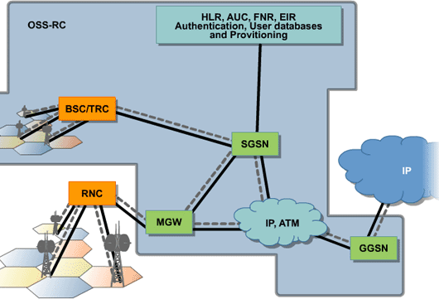
The Serving GPRS Support Node (SGSN) and the Gateway GPRS Support Node (GGSN) are the main network elements in the GPRS part of the core network. Operation and maintenance of a node is typically performed from a management client with the node as a server, for example, from the node management terminal.

WCDMA Sub-Networks

CORE NETWORK PACKET-SWITCHED DOMAIN

SGSN
The SGSN is a primary control node in the WCDMA Core Network providing mobility and session control for the UE. The mobility function makes it possible for the UE to move in the GPRS serving area by activating routing area updates and handovers whenever required. The SGSN establishes a logical link towards the UE and a session towards the Internet. It also enables the UEs to access all network services.
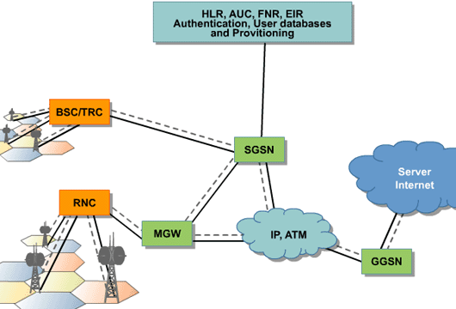
The SGSN contains the control logic to establish links and forward incoming and outgoing IP packets addressed to/from an UE that is attached within the SGSN service area. The WCDMA traffic is routed to SGSN and UE via RNC.
The SGSN serves all WCDMA subscribers that are physically located within the geographical area, SGSN service area. An SGSN performs functions in packet calls, similar to those an MSC performs for speech.

WCDMA Sub-Networks

CORE NETWORK PACKET-SWITCHED DOMAIN

GGSN
The Gateway GPRS Support Node (GGSN) is the gateway between mobile radio core network and other packet data networks, such as the Internet, corporate intranets, and private data networks.
In this role, the GGSN is responsible for session management within the mobile network, as well as for encapsulation and de-encapsulation of bearer traffic sent to and from Serving GPRS Support Nodes (SGSNs).
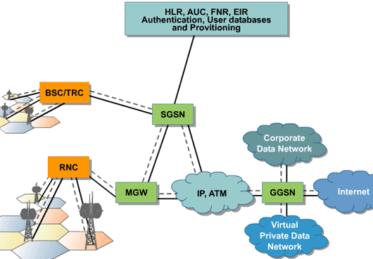
From the external IP network’s point of view, the GGSN acts as a router for the IP addresses of all subscribers served by the GSM/WCDMA network. Routing to the correct SGSN and protocol conversion is also provided by the GGSN.
The GGSN in the current release of the GSM/WCDMA networks are using on J20 platform. This is a new one that has redundant routing engines, redundant switch system boards, redundant power supplies, and redundant cooling fans, which significantly offer increased reliability. Moreover, the J20 GGSN offers complete fault tolerance and as well, an exceptional software stability ensured by separated routing engine and forwarding engines.

WCDMA Sub-Networks

CORE NETWORK PACKET-SWITCHED DOMAIN

CNPS Domain Architecture
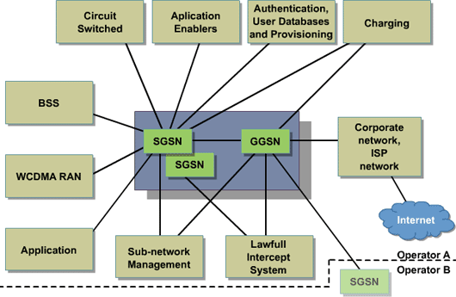
The packet switched domain complies to 3GPP standards but is not split. The SGSN controls the logical connections with the UE and the sessions towards the IP network.

WCDMA Sub-Networks

USER DATABASES, AUTHENTICATION AND PROVISIONING

Home Location Register, HLR
The Home Location Register (HLR) is a real time mobile telecommunication node for Ericsson’s WCDMA system fulfilling the 3GPP specifications. The HLR node is designed with maximum consideration to economy for very high subscriber densities in large urban areas.
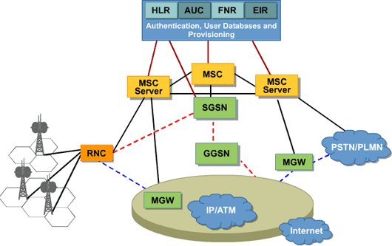
When the subscription is sold the operator enters the mobile identity, subscribed services and several other parameter in the network. The HLR holds all this data together with the current location and takes a fundamental part in the set up of calls in the network, as well as controls the roaming of the subscribers. The HLR application based on a modular concept provides flexibility in various network topologies.

WCDMA Sub-Networks

USER DATABASES, AUTHENTICATION AND PROVISIONING

Authentication Center, AUC
The Authentication Center (AUC), originally a GSM-specific application, produces information to verify the identity of mobile subscribers upon request from the Home Location Register (HLR). The AUC has now been adapted for WCDMA Systems standards as well. The main purpose of the security features included in the WCDMA Systems version of the AUC is to provide enhanced authentication processes in the 3rd Generation of mobile networks, thus preventing the weak points presented by the 2nd Generation (2G) networks. The WCDMA Systems AUC offers the same or better security than the fixed network
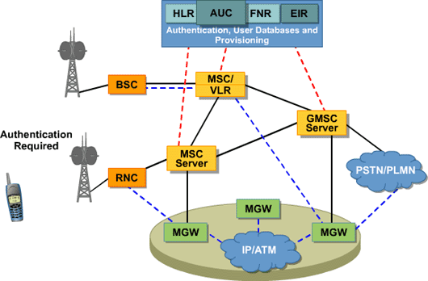
The basic functional responsibility of the AUC is to provide authentication and ciphering data. Authentication is performed to ensure that the mobile subscriber accessing the network is the one he/she claims to be. Ciphering is needed to ensure the privacy of the subscriber information, that is, speech, data, and user-related signaling elements (for example, International Mobile Equipment Identity, or IMEI; International Mobile Subscriber Identity, or IMSI; and Mobile Station ISDN, or MSISDN). Ciphering is performed on the radio path between the mobile and the radio network to ensure privacy and confidentiality of the communication over the radio path.

WCDMA Sub-Networks

USER DATABASES, AUTHENTICATION AND PROVISIONING

FLEXIBLE NUMBERING REGISTER, FNR
The Flexible Numbering Register (FNR) is a real time mobile telecommunication node for Ericsson’s GSM and WCDMA system fulfilling the 3GPP specifications.
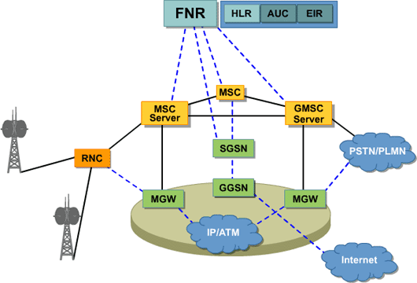
The FNR node supports two main independent functions: Flexible Allocation of MSISDN and Mobile Number Portability functions. Both functions can be simultaneously active in the node.
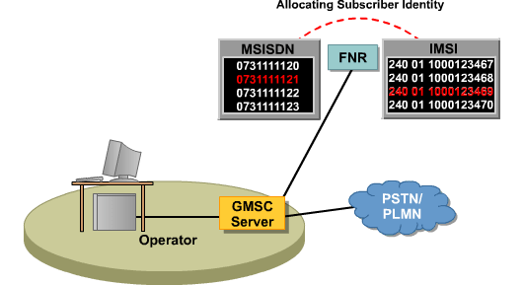
The Flexible Allocation of MSISDN function administers MSISDN and International Mobile Subscriber Identity (IMSI) relationship providing mobile operators with the ability to allocate a subscriber identity in a flexible way without considering the existing attachment between the MSISDN and IMSI series. Without the function the operator should tie a dedicated MSISDN number series to each HLR and make the routing table in the GMSC accordingly. The function allows the operator to allocate any MSISDN to any HLR, just inform the FNR about it. The GMSC doesn’t need any MSIDN routing table pre-implemented.

WCDMA Sub-Networks

USER DATABASES, AUTHENTICATION AND PROVISIONING
The Mobile Number Portability function enables a mobile subscriber to retain their subscriber directory number (MSISDN) when changing network operators. The subscriber shown in the here changed the subscription from Operator A to B keeping the same MSISDN.
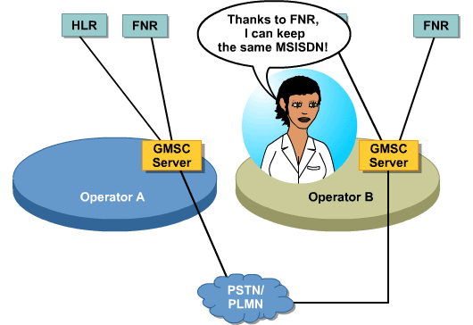

WCDMA Sub-Networks

USER DATABASES, AUTHENTICATION AND PROVISIONING

EQUIPMENT IDENTITY REGISTER (EIR)
The EIR database validates mobile equipment. The MSC/VLR can request the EIR to check if an MS has been stolen (black listed), not type-approved (gray listed), normal registered (white listed), or unknown.
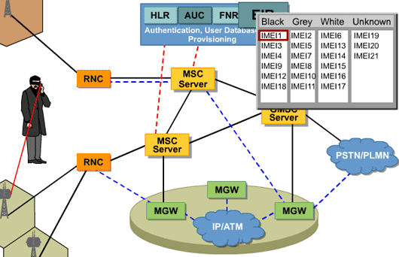

WCDMA Sub-Networks

WCDMA RAN

Introduction
WCDMA RAN (Radio Access Network) corresponds to Universal Mobile Telecommunications System (UMTS) Terrestrial Radio Access Network (UTRAN) in 3GPP specifications.

WCDMA RAN Architecture
WCDMA RAN is the Radio Access Network for WCDMA Systems that connects the Core Network (CN) and the User Equipment (UE). The WCDMA RAN also comprises interfaces towards different external management systems.
The following RAN functionality is covered:
- Radio Network Controller (RNC)
- Radio Base Station (RBS)
- Radio Access Network Operation Support (RANOS)
- O&M Infrastructure (OMINF)
See the figure below for a depiction of the WCDMA RAN architecture:
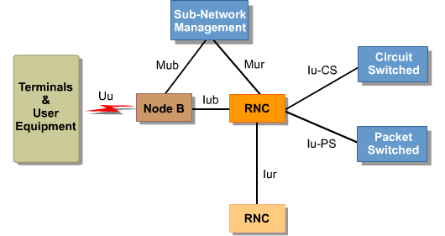

WCDMA Sub-Networks

WCDMA RAN

RNC
The Ericsson RNC 3810 is used as the Radio Network Controller for the WCDMA RAN system. RNC 3810 is a high capacity RNC with a scalable, modular architecture to support the variety of capacity requirements required in different networks and deployment phases. The RNC is in charge of controlling the use and integrity of the radio resources. The unit can handle different types of RBSs and a time-varying traffic mix between packet and circuit services, such as, voice and IP traffic. Depending on the UE state the RNC roles are:
- SRNC. Serving RNC is the node controlling the resources used by UE
- DRNC. Drift RNC is the node controlling the second RBS in the Soft Handover case
- Controlling RNC, CRNC. Each RNC acts as Controlling RNC for the directly connected Node B’s and their cells

RBS
The RBS (Radio Base Station) 3101,RBS 3202, and RBS 3104 belong to the RBS 3000 family and are used as radio base stations for the WCDMA RAN system. These units provide both indoor (3202) and outdoor (3101, 3104) installations. The RBS provides radio resources and maintains the radio links to the UE within cells. The RBS also handles radio transmission and reception in one or more cells to and from the UE.
With the RBS 3000 family, Ericsson provides products for single sector and multiple sector configurations. The architecture of the RBS 3000 supports a number of configurations and establishes a basis for future development of RBSs supporting macro, micro and Pico cell structures.
The RBS 3000 models facilitates a cost efficient solution for different network configurations based on different capacity, coverage, power supply source, space and environmental requirements.
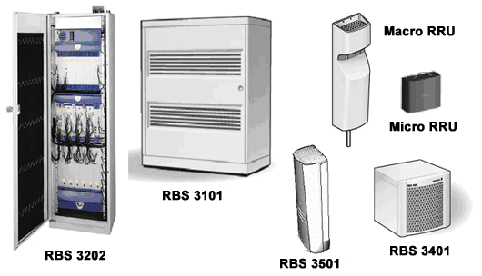

RXI 820/810
Ericsson’s RXI 820/810 Real-time Router has been developed in response to specific requirements associated with a new generation of IP and ATM-based wireless networks. The real-time IP routing and ATM aggregation features of the RXI 820/810 makes it ideal for deployment in wireless access networks, allowing for a smooth migration from ATM to IP. The RXI 820/810 can be used as:
- A real-time IPv4/IPv6 router
- An ATM/AAL2 aggregator
- As a combined ATM/AAL2 aggregator and real-time IPv4/IPv6 router
These three options can be combined with the feature of carrying TDM connections over ATM or IP networks through circuit emulation. This allows operators to carry legacy WCDMA traffic over the same ATM or IP network, which gives operational savings through the use of shared network resources.

Radio Access Network Operation Support (RANOS)
Radio Access Network Operation Support (RANOS) is a suite of software that handles O&M tasks for the WCDMA RAN. Therefore, RANOS provides the operation support system for Ericsson WCDMA RAN nodes. It provides the interfaces for transferring information from NEs to the Network Management Layer. RANOS provides a solid view of WCDMA RAN information, such as alarms, configurations, and basic performance. In addition, RANOS facilitates the integration of existing management systems with UMTS using a variety of standard interfaces and protocols.
RANOS is designed to support the day-to-day network operation and maintenance procedures. Coordinated management capabilities are provided including full status and properties views of the RNCs and the RBSs. The RANOS functionality includes alarm status and configuration data viewing, product searches on all the nodes, and performance monitoring of the WCDMA RAN. RANOS applications run on the RANOS Server. The corresponding GUI applications run as applets in a web browser on a thin client located anywhere on the O&M Intranet. RANOS can send data such as fault notifications or configuration data to the Network Management System.

O&M Infrastructure (OMINF)
The O&M Infrastructure (OMINF) makes up the components used to implement the O&M Intranet. This O&M Intranet is used to connect all NEs for O&M control signaling. OMINF is intended for O&M data traffic only (not for user data). The IP-based network for O&M signaling is called O&M Intranet and interconnects all NEs in the WCDMA O&M system.
The O&M Intranet enables the RNCs and RBSs to be controlled remotely using RANOS and the RNC and RBS Element Managers. This means that all O&M activities, such as Element Management of one or all the nodes in the WCDMA RAN, can be performed anywhere on the O&M Intranet

WCDMA Sub-Networks

LAWFUL INTERCEPT MANAGEMENT SYSTEM (LI-IMS)

Introduction
The Lawful Intercept Management System (LI-IMS) is a mediation node that forwards Intercept Related Information (IRI) and Content of Communication to one or more Law Enforcement Agencies (LRA). Administrative interaction between the LRA and a Core Network node is also exchanged via LI-IMS.
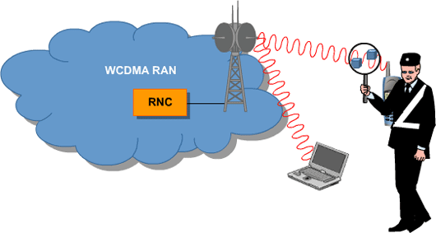
Lawful interception is the activity that allows law enforcement agencies to access end-users in a packet switched service environment. This feature enables the operator to fulfill national or state security organization requirements to monitor packet switched traffic for specific end-users and/or terminals.
For lawful intercept the WCDMA System supports all relevant 3GPP and ETSI specifications.

WCDMA Sub-Networks

LAWFUL INTERCEPT MANAGEMENT SYSTEM (LI-IMS)

LI-IMS Architecture
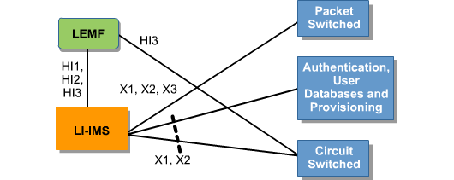
The Operator’s network is used for connecting each Network Element (NE) to the common LI-IMS. In the standard two new functions are introduced:
- The Administration Function, ADMF, for activation/deactivation of the interception as well as controls all the other attending network elements. Because of its central role in lawful interception, the security requirements for ADMF are very strict. ADMF contains an (user) interface for both Authorisation Authorities (AAs) and Law Enforcement Agencies (LEAs).
- The Delivery Function, DF, for delivering the intercept data to the LEAs. It receives the intercept data from GSM/WCDMA network elements, and arranges it according to LEA identity, target identity and direction of data transfer. DF delivers the intercept data to the correct LEA(s).

WCDMA Sub-Networks

LAWFUL INTERCEPT MANAGEMENT SYSTEM (LI-IMS)
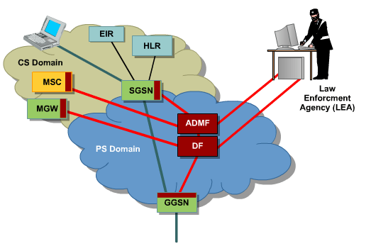
Basic Lawful Interception Functionality supported in current release:
- System Administration.
It is possible to administrate Network Elements (Intercept Access Points, IAP’s), Law Enforcements Agencies, LEA, and Law Enforcement Management Facilities, LEMF.
- Handling of Court Orders by the System Operator. Court order can be registered, activated, removed etc. via a GUI or an API
- Interception in the Intercept Access Points, IAP’s. The actual interception of IRI and Content of Communication (CC) is performed in the Intercept Access Points.
- Intercept Related Information, IRI, mediation to the LEMF. The IRIs are mapped on the relevant standard message, formatted and distributed to the Law Enforcement Monitoring Facilities (LEMFs).
- Sending the Content of Communication, CC, to the LEMF. The contents of communication are distributed directly from the IAP’s or from the LI-IMS, depending on node type.
- Security and service functions. The administration and IRI and CC distribution is handled via secure channels.

WCDMA Sub-Networks

TRANSPORT SOLUTIONS IN WCDMA

Transport in WCDMA System network consists of:
- Transport Solutions - Packet Backbone
- Transport Solutions - Radio Access

Transport Solutions - Packet Backbone
The Mobile Packet Backbone Network (Mobile-PBN) is a modular, scalable, and secure transport solution for the circuit-switched and packet-switched functions of the mobile Core Network.
Mobile-PBN provides a comprehensive feature set for GSM and WCDMA networks, including its key role in facilitating the transition towards a completely packet-based IP transport for mobile networks.
Mobile-PBN interconnects all the Core Network nodes (such as MSCs, GSNs, HLRs, and so on) and provides connections to the required external networks and elements (including RNCs, O&M networks, GSM/GPRS networks, ISPs, GRXs, PSTNs, ISDNs, Service Networks, and Corporate Access Networks).
The modular Mobile-PBN is both flexible and scalable. It consists of different module types combined to provide various additional network functions and services. This highly flexible design is standards-based, with all modules being pre-validated to function independently.
Mobile-PBN is a scalable solution and caters for mobile operator networks of all sizes, from small networks comprising only one site to very large networks containing hundreds of sites.
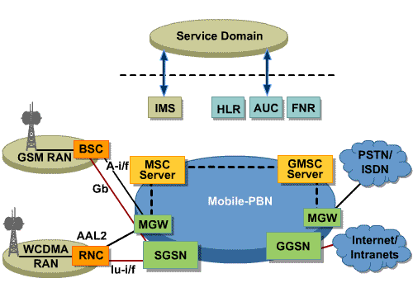
While transport is one important solution element, Mobile-PBN comprises modular solution components and provides additional functionality of great importance to a mobile Core Network. The following functions are included in the Mobile-PBN solution:
- A backbone solution for GSM and WCDMA networks (both for user and control traffic), based on IP and (optionally) ATM
- Secure Corporate Access
- Secure Roaming Gateway services
- Connectivity solutions for ISP and GRX networks
- A security solution for the whole mobile Core Network protecting user data, billing information, and network elements
- Additional server nodes needed in the network, such as DNS and RADIUS for address look-up and AAA
- An O&M transport solution (including FM, PM, CM, charging, and LI traffic)
- O&M applications for Mobile-PBN products (Mobile-PBN Management Suite
The Mobile-PBN solution segments the WCDMA mobile Core Network requirement by site type and function, and comprises modules that can be combined to fulfill the specific operator's service requirements.

WCDMA Sub-Networks

TRANSPORT SOLUTIONS IN WCDMA
The full Mobile-PBN reference solution comprises Primary, Secondary, and Concentrator Sites. These sites are redundantly interconnected providing maximum network resilience.
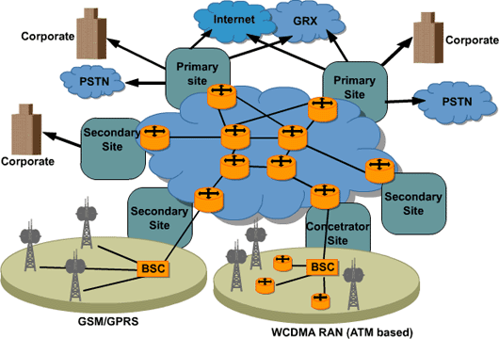
Primary Sites host the main functional elements of GSM/WCDMA networks, including service nodes, servers, and external network connectivity. Examples of elements and functions within the Primary Site include SGSNs, GGSNs, MGWs, MSC servers, HLRs, and optional O&M and LI functionality. They also offer ISP, GRX, and corporate connectivity. Primary Sites, like Secondary and Concentrator Sites, contain a transport module providing inter-site routing and switching capabilities.
Secondary Sites serve as distribution sites and are dual-homed to Primary Sites providing connectivity to other PLMNs, the Internet, and corporate customers. Secondary Sites aggregate traffic from Concentrator Sites to the Primary Sites. Concentrator Sites aggregate and transport GSM and WCDMA subscriber traffic to Primary and Secondary Sites.
Concentrator Sites also provide connections to local corporate networks.
The Mobile-PBN IP transport design is built using high-performance core IP routers and Ethernet switches. ATM traffic is transported over the backbone using layer 2 transport technologies, which allow ATM or Frame Relay connectivity over MPLS backbones. This functionality is provided by Ericsson's AXI 520 IP Router family.
A pair of AXI 520 routers is located at each site, creating the core functionality of the packet backbone network. These site routers are redundantly inter-connected via Gigabit Ethernet links within the sites and via Packet-over-SONET or Synchronous Digital Hierarchy (SDH) between the sites. All user traffic inside the core is directly SDH-encapsulated MPLS traffic.
The edge functionality is provided by the same site routers, which are configured as combined MPLS label edge routers (LER) and label switch routers (LSR). MPLS is used to provide BGP-based VPNs. MPLS is also used in conjunction with standards-based layer 2 VPN technologies to provide ATM and Frame Relay transport across the backbone network. The AXI 520 routers support MPLS, either as LERs or LSRs, and provide Class-of-Service-based packet forwarding.
Connectivity and traffic separation are provided by a combination of Ethernet switches and site routers. Ethernet switches provide VLANs and 100/1000 Mbit/s Ethernet interfaces. Ericsson's AXI 520 site routers feature a wide range of interface types and service-provider-proven routing protocols, such as OSPF and BGP-4.
The Mobile-PBN IP/ATM transport design uses the proven "IP/ATM Overlay" model. In contrast to the "MPLS-integrated" approach, the overlay model uses a layered architecture where the AXI 520-based IP/MPLS connectivity is transported on top of ATM PVCs.
The core of backbone network is built using high-performance multi-service switches, that is, Ericsson's AXD 30x product family. Any combination of IP/MPLS, ATM, Frame Relay, and circuit emulation services can be delivered using this carrier-class ATM switch. Furthermore, due to its telecom-grade characteristics, only one switch is required at each site. The ATM switches are redundantly interconnected by ATM links.

WCDMA Sub-Networks

TRANSPORT SOLUTIONS IN WCDMA

Transport Solutions - Radio Access
In order to have a radio network up and running in an efficient way, it is necessary to add the transmission and transport infrastructure, which are described in this chapter. The WCDMA Radio Access transport solution contains:
- Infrastructure that enables the communication between the Network Elements in the WCDMA RAN
- Transmission that aggregates the traffic on the links between the RBSs and the RNCs

Radio Access Network Aggregator (RANAG)
The Ericsson RXI 820 ATM product in WCDMA RAN (acting as RANAG) provides transmission, by aggregating ATM traffic from low-speed transmission links from the RBS to high-speed transmission links to the RNC. An RXI 820 ATM hub site provides significant aggregation gains.

TNINF
TNINF enables communication between the different NEs in the WCDMA RAN and between the WCDMA RAN and the CN. The Transport Network can be built either with external ATM and Plesiochronous Digital Hierarchy (PDH) and Synchronous Digital Hierarchy (SDH) equipment, or with direct connections, such as fiber lines, copper lines, or microwave systems. All connections between NEs use ATM-based transport protocols. The NEs can, therefore, be interconnected either through direct physical layer transmission services, such as those provided by a PDH or SDH network, or through an intermediate ATM network.
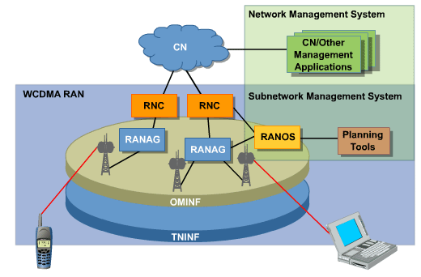

WCDMA Sub-Networks

WCDMA NETWORK MANAGEMENT ASPECTS
Network management is the fundamental underlying layer of telecom management. It is the set of functions required from a sub-network interface by telecom management to enable controlling, planning, allocating, deploying, coordinating, and monitoring the resources of the sub-network.
The functional areas of Ericsson's WCDMA network management include the following:

Fault Management
Fault management is the detection and correction of abnormal network operation. It provides the means to collect and correlate alarms from the network elements and to present this information to the network operator, in a clear and meaningful way. This information is presented so that the appropriate corrective action can be taken as quickly as possible. The operator's revenue is thereby preserved by minimizing the time that a particular service cannot be provided due to a fault situation. Consequently, the end-users QoS perception is enhanced.
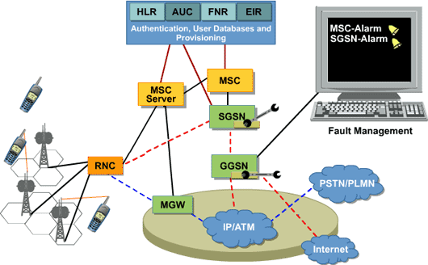

Configuration Management
Configuration Management encompasses activities, such as providing and updating the network elements with the data, parameter settings, and connectivity information necessary for them to provide the services and functions within the network for which they were intended. This also includes software update and maintenance.
It consists of the following main parts:

Node deployment
These are the installation / routine configuration tasks normally carried out on a managed element.

Connection management
This involves the deployment of associations across the network between managed elements to carry traffic or signalling.

Inventory Management
Inventory management provides information on all equipment in the network. It presents a view of hardware assets, software versions, and configurations. An example of configuration information is a view of logical entities available to the network, such as network connection terminations defined that are available for use.

Topology Management
This is a layered information tool that provides a view of all connections from physical to logical that can be discovered from the network.

Software Management
Software management is the controlled handling (from a central point, that is, the network management system) of upgrades and changes to the software versions running on network equipment.

WCDMA Sub-Networks

WCDMA NETWORK MANAGEMENT ASPECTS

Performance Management
Performance Management provides functions to report upon and evaluate the behavior and the effectiveness of the network or network element. Its role is to gather and analyze statistical data for the purposes of monitoring and correcting the behavior and effectiveness of the overall network, as well as that of the individual network elements. In addition, Performance Management plays an important role in facilitating network planning, dimensioning, provisioning, maintenance, and measurement of quality. In particular, it can be used to assist in verifying customer SLAs.
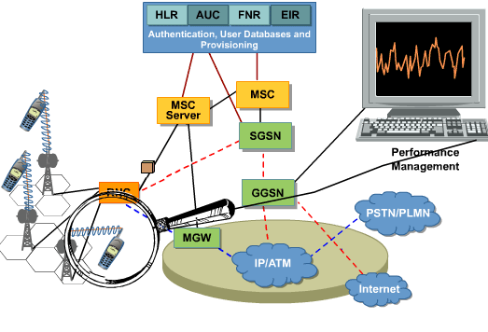

Security Management
Security management is the control and monitoring of access to a network, its elements, and the services it provides.
Element management provides the management interface from either a centralized point, that is, the network management system, to many managed elements or directly to each managed element.
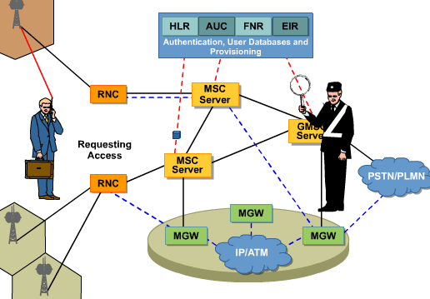

WCDMA Sub-Networks

WCDMA NETWORK MANAGEMENT ASPECTS

Network Management Solutions
The WCDMA System consists of several sub-networks and a network management solution is provided for each sub network. The integration of the specified functions for each sub-network towards an operator's existing or new Telecom Management infrastructure is performed at NMS (multi-vendor Network Management System). NMS can be considered an integrator to the Customer and Service management or can actually be used to perform these functions.
It is the NMS at the integration layer and the OSS suites of functions that Ericsson provides, which are focused upon here.
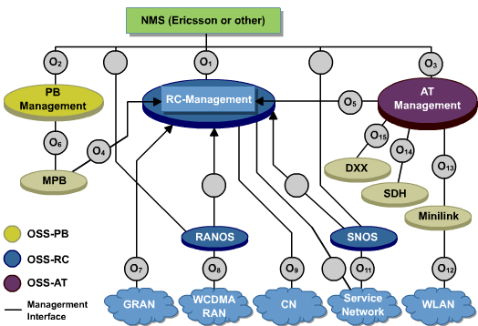

OSS-RC
Ericsson Mobile Network OSS (OSS-RC) is the Network Management solution for GSM and WCDMA Mobile Networks. Each product supports or implements one or more Network Management functions).
OSS-RC provides a framework and all specified network management functions for the GSM and WCDMA network management in the following ways:
- Common Platform - Aligned hardware and third party product licences
- Common functions and interfaces - (for example, FM, PM, and software functions) common applications for network supervision, performance monitoring, and Software Management
- Domain-specific functions - functions specific to each sub-network's technology are included, mainly for configuration management tasks.

RANOS
RANOS is aligned with but not integrated to OSS-RC. Later releases of RANOS will be integrated to OSS-RC but currently can share the same pyhsical hardware and environment. Any RANOS installation will be upgradeable to the fully integrated OSS-RC. RANOS provides network management for WCDMA Radio Access Networks. It supports all the specified network management functions for such a network.
The supported node list includes CPP nodes: RBS and RNC.

SNOS
SNOS provides network management for Service networks and many IP-based services where a generic service configuration interface is required towards the service providing managed elements. SNOS also supports the other specified network management functions. SNOS is an enabler in the Service Network Framework (SNF). As such, SNOS can manage any system that is SNF-compliant.

OSS-PB
OSS-PB provides network management for IP backbone networks. It supports all the specified network management functions for such a network.

OSS-AT
OSS-AT provides network management for access transmission networks (SDH, minilink..). Fault and performance data from OSS-AT can be escalated to OSS-RC for the purposes of engineering towards faults or traffic from the telecom network perspective down to the transmission layer. OSS-AT supports all the specified network management functions for such a network

WCDMA Sub-Networks

SECURITY IN WCDMA
Considering that IP is introduced at various levels in mobile networks, the exposure to threats and risk of attacks from new and unexpected venues (compared to the previous closed mobile networks) is very significant.

Network Security Perspectives
A site is a physical place that contains one or more nodes. The nodes all share the same level of trust. Therefore, they have the same requirement on perimeter protection, both logically and physically.
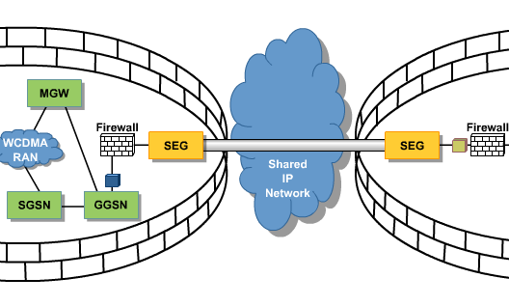
The normally very well-restricted physical access to a site, and in particular to the equipment hall(s) of the site, indicates that it is reasonable to assume a trust model where the site LAN can be considered trusted. Ericsson, therefore, believes in adopting a site-based approach also to the IT security architecture. With such an approach the site perimeter will include policy enforcement points to protect the traffic leaving the site (using IPSec-based confidentiality and/or integrity protection), as well as to protect the equipment of the site from entering potentially harmful traffic (firewalls, proxies, network intrusion detection, and so on). This also means that the security functionality of any individual network element or node residing on the site primarily will include different types of access control mechanisms (for example, basic packet filtering and access control) and accounting functions (for example, logging and host-based intrusion detection). An advantage of this type of solution would be that it minimizes any performance penalties that are due to the introduced security mechanisms. It would also make the security architecture easier to overview and, consequently, less costly to manage.

WCDMA Sub-Networks

SECURITY IN WCDMA
The types of security offered by Ericsson within WCDMA that address the operator's needs are, as follows:

Network Signaling Protection
Due to the fact that an IP network mixes all traffic, a vital mechanism for providing security in the networks is traffic separation. Signaling traffic, O&M traffic, and user traffic need to be separated to provide integrity. To provide an infrastructure supporting different security levels on the same hardware, traffic separation in the backbone is inevitable.
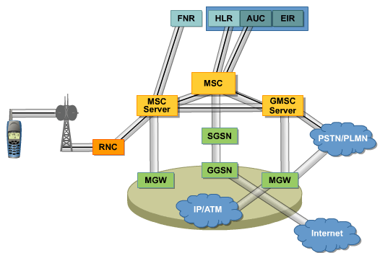

WCDMA Sub-Networks

SECURITY IN WCDMA

Network and Site Protection
In order to protect the site, a strong perimeter is needed.
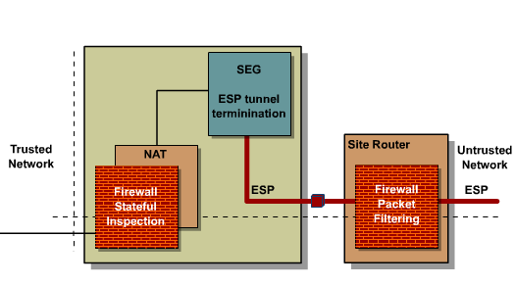
Packet filtering is performed when a packet enters the site. If the packet is encrypted it will be passed to the security gateway for decryption. The SEG then forwards it to a Stateful inspection Firewall, which conducts the packet filtering and stateful inspection.

WCDMA Sub-Networks

SECURITY IN WCDMA

WCDMA Nodes Security
To protect the nodes within the network sites, the nodes have the following set of security mechanisms:
- Basic access control mechanisms similar to basic packet filters
- Security logs that make it possible to trace security-relevant activities and events that have happened in a node
In the following section the security functionalities of specific nodes and solutions that are part of the WCDMA System are described. The description includes those nodes and solutions that are part of the end-to-end security functions described above.

Radio Access Network Security
Below, RANOS (Radio Access Network Operation System) and OSS-RC (Operation Support System for Radio and Core Network) are presented. Also, the Ericsson Mobile Corporate Access solution is described although it is applicable to any access.

OSS-RC & RANOS
Within Ericsson's telecom management portfolio, OSS-RC, including RANOS, are the main products for GSM/WCDMA Radio and Core Network management. The prime objective is service assurance, which is achieved through a wide range of features supporting all aspects of centralized operation of 2G/3G networks.
As described in the Specification section above, OSS-RC, including RANOS, supports basic security features, such as the following:
- Authentication, authorization, and Access Control of O&M personnel
- O&M Traffic protection
- O&M Network protection
- Security logs and audit trails

Core Network Security
Nodes and solutions that are physically placed in the Core Network are presented below.

AUC
The AUC generates authentication and encryption data, according to the 3GPP specification for WCDMA and the European Telecommunications Standards Institute (ETSI) for GSM. The purpose of the authentication security feature is to protect the network against unauthorized use. It also protects subscribers by preventing intruders from impersonating authorized users.

HLR
The HLR plays a decisive role in the GSM/WCDMA authentication process, where it offers support for the following standardized security functions:
- Subscriber identity authentication
- Network authentication
- Signaling and user data confidentiality
- Signaling data integrity
HLR also includes additional security and fraud mechanisms, such as the following: HLR redundancy, Roaming service restrictions, monitoring of call forwarding registrations, remote control equipment, load regulation, SCCP congestion control, policing for MAP, SCCP, and MTP.

MSC/VLR/MGW
MSC/VLR/MGW includes security functions that strengthen the operator's and the subscriber's security against illegal activities.
The main security functions of MSC/VLR/MGW are the following:
- Subscriber authentication
- Signaling and user data confidentiality initiation
- Algorithm negotiation
- Equipment identity check
- Subscriber identity confidentiality on the radio path
MSC/VLR/MGW has additional security and fraud prevention functions, such as equipment identity control, operator determined barring, enhanced IMEI check, call tear down, supervision and disconnection of long duration calls, policing of calls from grey-listed IMEI, and policing for MAP, MTP, and SCCP.

SGSN
The SGSN performs an authentication procedure to protect the SGSN against unauthorized use. The authentication procedure performs the identification and authentication of the service requester, as well as the validation of the service request type to ensure that the user is authorized to use the particular network service. After identification and authentication of the subscriber are performed, the SGSN forwards the ciphering keys and orders the RNC to apply encryption between the RNC and the MS.

GGSN J20
The GGSN provides an interface between the mobile network (WCDMA) and other packet data networks, such as the Internet, corporate intranets, and private data networks. In this role, the GGSN is responsible for session management within the mobile network, as well as for encapsulation and de-encapsulation of bearer traffic sent to and from Serving GPRS Support Nodes (SGSNs).
The optional Encryption Services PIC uses IPSec in tunnel mode to secure the Gi, Gn, Ga, and Gp links, as well as for linking to the network management system. Authentication Headers (AH) and Encapsulating Security Payload (ESP) with DES and 3DES are available. Authentication is also supported within ESP. Key distribution with IKE is supported, using Diffie-Hellman key exchange, based on pre-shared keys.
Virtual private networks (VPNs) enable separation of different customer's bearer traffic and routing or reach ability signaling traffic over a common IP-routed Core Network. Different types of VPNs can allow customers to use overlapping private IP address spaces, to have independent virtual views of logical network topology, to protect traffic cryptographically, or to use combinations of these options.
The RADIUS client in the GGSN J20 supports IP address allocation, end-user authentication on the IP layer, and accounting.
The Packet Forwarding Engine (PFE) includes packet-filtering functionality for increased security.

Equipment Identity Register (EIR)
The purpose of the EIR is to provide information to enable measures to be taken against stolen and faulty equipment. The EIR performs checks initiated by the MSC on the International Mobile Equipment Identity (IMEI) that is being used by a mobile subscriber.
There is also a possibility to interface with the Central Equipment Identity Register (CEIR) that has been set up for GSM. The prime purpose of the CEIR is to enable handsets stolen from a subscriber on one network to be placed on a black-list and barred from being used on any GSM network.
The EIR also includes functionality for logging suspicious events and to apply intelligent fraud detection software in order to analyze those logs.

WCDMA Sub-Networks

SECURITY IN WCDMA

Service Network Security
Functions and enablers in the service network with essential security roles are described below:

Mobile Internet Enabling Proxy (MIEP)
MIEP is the bridge between the mobile network and the applications on the Intranet and Internet. MIEP acts as a performance enhancing proxy by supporting wireless protocols, such as WAP and W-HTTP/TCP, thereby avoiding unnecessary signaling across the radio interface.
MIEP is WAP2.0-compliant and also includes functionality contained in WAP Gateway/Proxy4.0.

AAA Server
The AAA Server is designed to provide centralized authentication, authorization, and accounting functions offering end-users means to obtain secure Internet access and facilitating the usage of Mobile Internet and 3G services. In addition, the AAA Server establish a path for the evolution of subscriber database solutions into 3G network architectures.

Charging Systems
To further increase the security for both the user and network operator, the security concept for charging focuses on protecting from internal fraud. The following security mechanisms are offered in this regard:
- Encryption of the Voucher Database is performed in order to prevent unauthorized access
- Security logs are generated and stored in protected mode from modification and deletion of unauthorized employees
- Authorization profiles are introduced to define access rights for O&M personnel
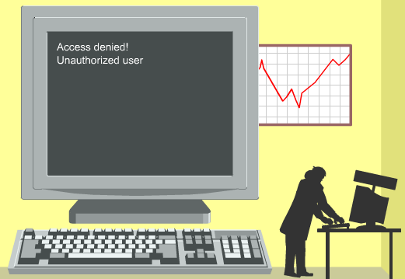

Mobile Positioning System (MPS)
MPS is the Ericsson Mobile Positioning System, which is discussed further in more detail.
A privacy profile is stored for each user in the HLR and is downloaded to the MSC/VLR, similar to any other subscriber data. This allows very advanced privacy settings.

Service Network Operation and Maintenance (SNOS)
Ericsson Service Network Operational System (SNOS) is the single point of O&M in the area of Ericsson Service Network.
The following main security features are implemented:
- Authentication and authorization of O&M personnel are enforced.
- SNOS offers an extensive set of security logging facilities.
- Secure protocols are used for remote management (for example, ssh, sftp).
- A physically separated network is recommended for O&M traffic.

Connectivity Network Security

Security Appliances
Ericsson is using NetScreen Technologies Inc as a partner for offering firewalls, VPN gateways, and NAPT (Network Address Port Translation) functionality. The NetScreen products can be tailored to fulfill a number of needs. In the product offering the following appliances have been defined:
- Security Gateways, as defined by 3GPP specifications
- Firewalls tailored for the Gi interface, including NAPT functionality
- GTP-aware firewalls, that is, firewalls specifically tailored for state inspection of GTP traffic
- VPN gateways with support for 3DES
- Application Layer Gateway (ALG) support for NAPT traversal
- Intrusion Detection System

Mobile-PBN
Multi-layered security is a key feature of the Mobile-PBN, built-in to the modular design. Separate security zones are created by the Mobile-PBN sites, and protected, according to their assessed risk levels. Access from zone to zone is only provided where necessary, reducing the risk of intrusion.
Firewall pairs guard the boundaries of each security zone, providing stateful inspection and filtering of various traffic types, according to operator-specific security policies. Additional perimeter defense is available as an option to guard boundaries where roaming partner networks connect. Dual high-performance GTP-aware firewalls can prevent various types of Denial of Service (DoS) attacks and provide protection from fraud. Additionally, other network elements, such as the AXI 520 IP Router can prevent DoS attacks.
MPLS-based VPNs provide additional levels of security and traffic separation, according to RFC 2547bis. Data can be further protected by the use of IPSec tunneling with 3DES ESP data encryption.

IP Infrastructure
A vital part of the Service Layer is the IP Infrastructure 1.0, a communication platform and network deployment environment for services and service enablers, providing them with features, such as network security, high availability, and scalability. This means that all the service layer security mechanisms are implemented in IP Infrastructure 1.0, thereby relieving services and enablers from implementing security features or functions for themselves.

Introduction

Lesson Objectives
Upon completion of this lesson the student will be able to:
- Describe the WCDMA Service Network
- Describe the Service Network Framework, SNF

Service Network, Introduction
The service network is a layer on the top of the control and connectivity layers implemented in the WCDMA Core Network.
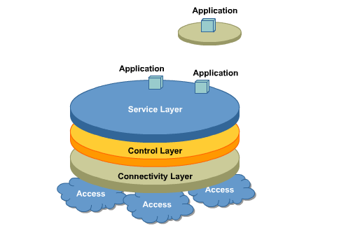
The Service Network in WCDMA is a highly competitive environment where the operators need to develop and launch new, easily accessible services that will help them in their bid to attract end-users and retain existing ones. Reaching these objectives is dependent on several factors that affect the service network.

Service Network, Introduction
First, there is a need for open environments that do not restrict operators in what they can use or offer. There is also a need for a high degree of flexibility in managing services, the third-party partners, and the charging arrangements between them. By implementing open Application Programming Interfaces (APIs) the service network takes advantage of the WCDMA Core and Access subnetworks functions and establishes sessions between the end users and the requested service.
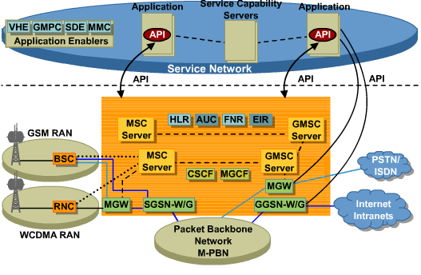

Service Network, Introduction
Secondly, to allow for future growth, the service network must be flexible and scalable. The operators must enable rapid development and a subsequent launch of services. However, the implementation requires in-depth technical knowledge, skill and business expertise plus the ability to manage numerous interrelationships between third parties, such as:
- service providers
- content providers
- application developers
- equipment suppliers and software vendors
These parties are the driving forces forming the sharing, content, and the provisioning of services and applications.

The use of a standards-oriented and product-neutral reference architecture is instrumental in delivering well-designed service networks which possess the set of technical qualities that is required to efficiently, flexibly and reliably deliver functionality in the service layer.

Service Network, Introduction

The Service Network Framework, SNF
The Ericsson reference architecture for creating horizontally layered solutions in the service layer is called the service network framework (SNF). This is defined as an architectural framework that consists of reusable designs for products and solutions in the service layer.
The architectural framework of the SNF is expressed using a set of architectural views. Each view provides insight into a particular architectural aspect as:
- domain
- structure
- system type
- deployment
- tier
- data model
- applied
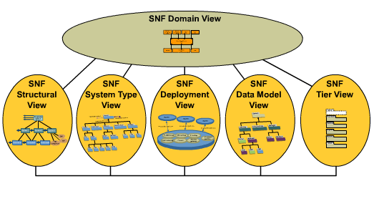
Each view works in concert with the other views to capture the architectural statements provided by the framework and, over time, to enable the addition of further statements. In addition, the architectural rules and best practices, which are presented along functional and qualitative lines, add support in helping to apply the architecture and provide guidelines. These are held in the SNF rule and SNF guideline catalogs respectively.

Service Network, Introduction

The Service Network Framework, SNF

Domain view
The domain view describes an ideal boundary for the service network and defines how the service network interconnects and collaborates with other systems present in its environment.
The domain view captures and reflects the SNF view of the service network environment and identifies the domains with which service networks generally collaborate, making explicit the demarcation and interfaces between it and other domains.
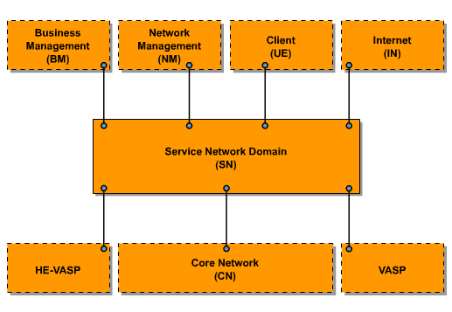

Service Network, Introduction

The Service Network Framework, SNF

Structural view
The structural view provides a set of abstractions that architects can use for uniformly analyzing, modeling and expressing SNF architectures. Uniform expression is a necessity for creating solutions from a portfolio of reusable systems.
The highest level in the view is a compound system, which consists of one or more systems. Much of the architectural guidance in the SNF comes from what it terms the system level, which defines a system as a logical and modular building block that provides certain services over established interfaces. A set of systems works as such a building block to deliver the services that are available in a service network.
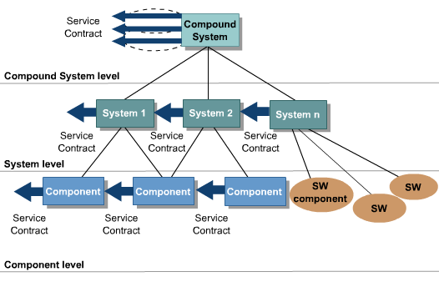
A service is an object that represents a collection of functionality accessed via protocols. The service is the SNF mechanism for indicating interfaces. One or more services may be provided from a compound system, a system or a component.
Finally, within this view, the service contract is the description that specifies how a service can be accessed. It is a combination of the functionality in the service and the protocol transfer mechanisms. The service contract is independent of, and is not connected to, a specific compound system, system or component. Normally the Service Contract is open in form of an API. The figure here shows the structural view for an IP Multimedia service provided by an operator.
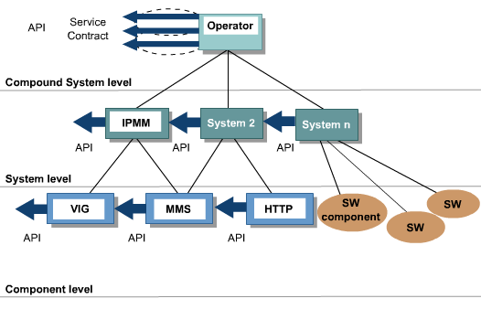

Service Network, Introduction

The Service Network Framework, SNF

System type view
The system type view introduces and specifies a recurring set of SNF systems, which are a set of logical building blocks for creating service networks. Each system type plays a special role in a service network and is specified in terms of responsibility and service (interface).
Solution architects may thus refer to system types as specifications for logical building blocks within the service network.
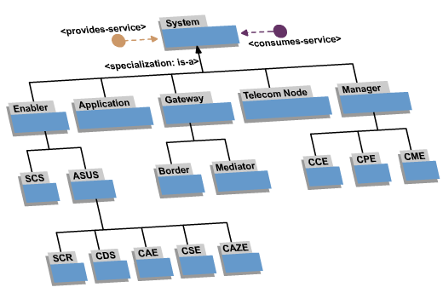

Service Network, Introduction

The Service Network Framework, SNF

Deployment view
Much of the SNF architecture rests on the assumption that Internet protocol (IP) connectivity is present in the complete solution. Core network (CN).
The IP network is a key aspect of the deployment environment for every system in the service network. The SNF deployment view provides guidance for ensuring that the IP network possesses a set of common services and qualities on which every deployed system can rely. Examples of common services include naming, addressing, routing, load-balancing, firewall and security gateway services. Likewise, common qualities include performance, scalability, flexibility, security, and high availability.
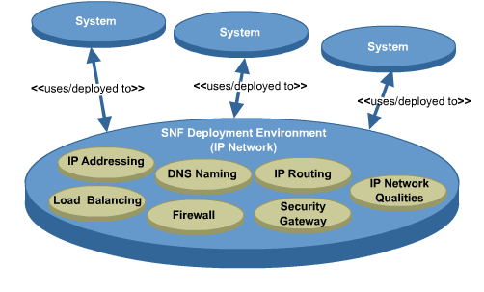
Figure here presents a conceptual depiction of how systems are deployed to, and make use of, an IP network with various common services and qualities.
An example of how a highly available IP network infrastructure can be realized when systems are deployed onto virtual local area networks (VLAN) is shown here.
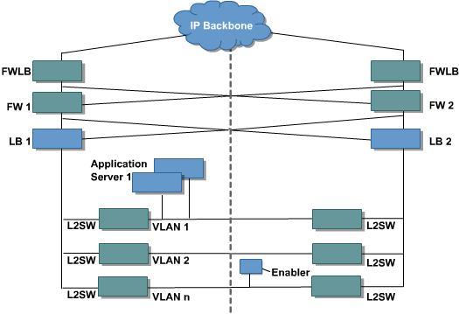
In this example, the application servers have been deployed on VLAN 1, whereas the gateways have been deployed on VLAN n.

Service Network, Introduction

The Service Network Framework, SNF

Tier view
The use of N-tier architectures is an accepted and proven approach toward partitioning or organizing distributed computing architectures that require high levels of scalability and availability. The SNF recommends that N-tier architecture should be employed for organizing systems into scalable and available solutions in a distributed computing environment.
The various tiers include client, presentation, business, integration, resource, and data. The client tier is concerned with every device that accesses systems or applications.
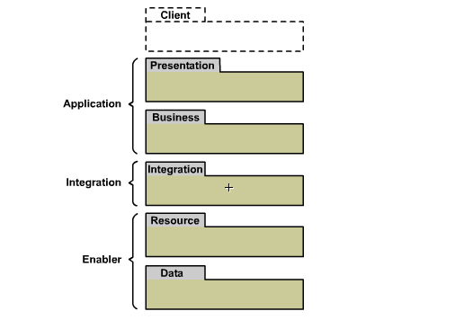

Service Network, Introduction

The Service Network Framework, SNF

Data model view
Data modeling is an important part of all architectural efforts. The SNF data model view specifies a uniform data model for user and service-related data and associated provisioning within the service network. The SNF data model has been designed:
- to support various business and service life-cycle models
- to enable designs that distribute user related data throughout the service network
- to support and enable the SNF common provisioning model
- to support information on how services are dependent on various systems
- to support extensions that accommodate solution-specific requirements
Deployment of the data model is generally made through a directory server (system type Common Directory System, CDS) within an actual service network. Although the data model can be used to provide access to all user and service related data in a service network, it does not necessarily follow that all data is modeled within the data model. Instead, data can be referenced, which allows for easy integration of existing, stand-alone data models, called affiliate data models. This gives the solution architect room to design service networks using the main data model and affiliate data models.
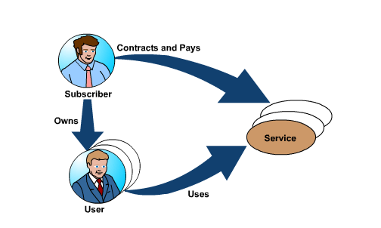

Service Network, Introduction

The Service Network Framework, SNF

Applied view
The applied view introduces the SNF blueprint, which provides a reference architecture that maps SNF system types, their interfaces, and collaborations to a single view. Some typical and important collaborations depicted in the SNF blueprint are:
- the central provisioning entity (CPE), CDS, and system component registry (SCR) - to achieve common provisioning of SNF systems that require provisioning
- the central management entity (CME) collaborating with all other SNF systems - to achieve common management
- the common charging entity (CCE) collaborating with all other SNF systems - to achieve common charging
- the border gateway (BGW), central authentication entity (CAE), and central session entity (CSE) - to achieve single sign-on for HTTP
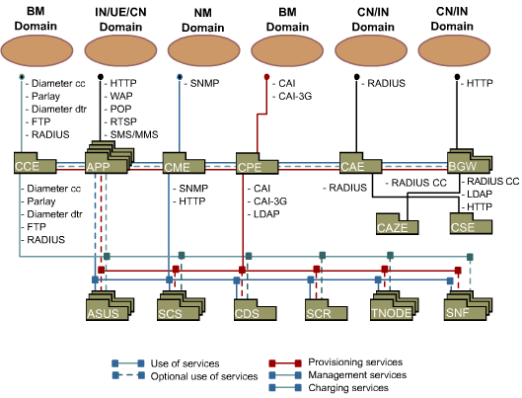

Introduction

Lesson Objectives
Upon completion of this lesson the student will be able to:
- Describe the main functions in WCDMA
- Describe the WCDMA network Services:
  - Telephony call service
  - Packet call service
  - Supplementary services
  - Multimedia Messaging
  - Streamed services
  - Videotelephony
  - Browsing
  - Location-based services
  - IN services
  - Single Sign On Service

WCDMA System Functions & Operator Services

Mobility Support
Mobility management allows a subscriber to move around geographically. It provides functionality to keep track of subscribers or User Equipment (UE), so that they can be reached from the network, in case of a terminated session. It also contains functions to ensure that a session is maintained during geographical movements, and that a subscriber has a seamless experience in the process.
In WCDMA Systems, mobility management depends on the state of the UE. Basically, when the UE is attached, it can be either Idle or Connected.
When the UE is Idle, the mobility management is mainly controlled by the UE itself. The UE will read system information and use it to determine when to perform the UE internal cell-reselection procedure and when to report location changes to the network. The network will respond to such information from the UE by updating stored location information, which is used to reach the UE from the network side, that is, in case of a mobile terminated session set-up request.

The idle mode mobility management, which includes Roaming and Cell-Reselection, largely involves the UE and the WCDMA Core Network, that is, the WCDMA Radio Access Network is not involved except for transporting the signaling messages between the UE and the Core Network, and broadcasting of cell-information which guides the UE in the cell-reselection procedure. The WCDMA Network provides functionality to support Inter- and Intra-PLMN Roaming and Cell-Reselection within the WCDMA Radio Access Network. Inter- and Intra-PLMN Roaming and Reselection are also supported to and from GSM.
In connected mode, however, the Core Network relies on the Radio Access Network to track the UE and will, except for special cases, forward and receive user data to/from a fixed anchor point (an RNC) in the Radio Access Network. The WCDMA RAN is in charge of assigning resources for the connection. The RAN can assign either common channel resources or dedicated channel resources.

WCDMA System Functions & Operator Services

Mobility Support
Mobility management is guided by a state machine, which is present in the CS core network domain and in the PS core network domain. These two state machines are independent, which means that no relation between the states in each domain exists, except if it is forced by the UE or application implementation to act as such.
The state in each state machine (domain) is stored in both respective network domains and in the UE. The network domain state and the UE state is synchronized, except for the signaling delay between the UE and the core network domain. The basic principles and the implied symmetry between the two domains are outlined in the figure below
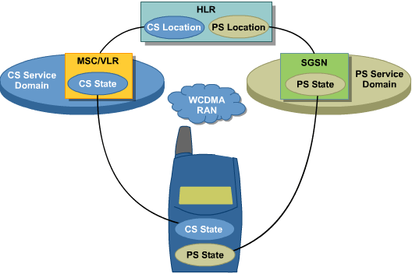
Mobility is managed by separate states in the PS domain and the CS domain of the core network. The state value is maintained in the core network serving nodes (MSC and SGSN) and in the UE.
Each state machine has three different states: detached mode, idle mode, and connected mode. For the two state machines, these states are referred to as CS MM (Circuit-Switched Mobility Management) state and PMM (Packet Mobility Management) state. For example, a UE can be in CS MM connected mode and PMM idle mode at a certain time, meaning that the CS state machine is in connected mode and that the PS state machine is in idle mode.
Detached mode means that the UE does not communicate with the respective domain in any direction. If the UE is switched off it will be detached in both domains. Depending on the UE implementation, attachments can be made to either domain or both.
Attaching to a domain implies that the UE registers with the respective domain via a radio control channel. This registration cannot be initiated from the network, due to the fact that in detached mode the UE is not reachable by the network.

WCDMA System Functions & Operator Services

Mobile Telephony Call Function
The mobile telephony call WCDMA system function provides support for a number of different call cases:
- Mobile network user making a call to a user belonging to the same network
- Mobile network user making a call to a user belonging to another network (can be both another mobile network or a fixed network)
- User belonging to another network making a call to a mobile network user
- Mobile network user making an emergency call
- Dual Tone Multi Frequency (DTMF) tone generation during an ongoing call
The Traffic Control in the MSC gives an almost unlimited number of routes, alternative routes, and elements per route. Certain calls (for example, emergency calls, calls to a certain B-number) can be provided with a higher priority than others when allocating resources such as processor capacity or outgoing trunks.
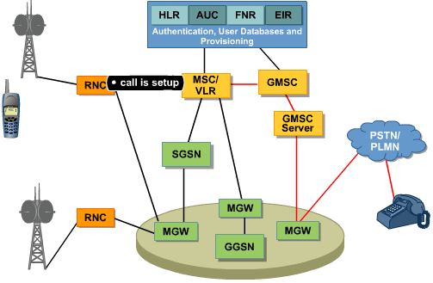
Calls to a mobile user are always routed to a Gateway MSC (GMSC). The GMSC analyzes the received MSISDN number and interrogates HLR for routing information. MSC/VLR receives a request for roaming number provision from HLR. The MSC/VLR identifies the mobile user by means of the IMSI, allocates a roaming number, and sends it back to HLR. The roaming number is only used during the routing and is released immediately upon reception of an incoming call in the MSC/VLR. When the routing information is received in GMSC the call re-routing is started and the call is set up through the network to the MSC in which the mobile user is located.
The emergency call can be routed to the closest emergency centre by defining an emergency area category per cell, which then can be used for call routing in the MSC. DTMF tone generation makes it possible for a mobile user to send digits from the User Euipment (UE) to a remote end. In this context, "digits" refers to the digits 0 to;9, as well as the characters A, B, C, D, * and #. Each digit is represented by a specific tone (frequency). The DTMF tones are not generated by the UE, but by hardware in either the MSC or the MGW. This is done to avoid the speech coder distorting the tones. When the mobile user enters a digit on the UE, a signalling message is sent from the UE to the MSC, which initiates tone sending.

WCDMA System Functions & Operator Services

Mobile Internet / Intranet Access for WCDMA (Packet-Switched)
The WCDMA PS network makes packed data services available to WCDMA Systems. It provides a basic solution for Internet Protocol (IP) communication between User Equipment (UE) and the Internet or corporate Local Area Networks (LAN).
WCDMA PS offers the following services in WCDMA:
- Efficient transport of packets in the cellular network
- Efficient use of scarce radio resources
- Fast setup and access time
- Simultaneous circuit-switched and packet-switched services, which means coexistence without disturbance
- Connectivity to other external Packet Data Networks (PDNs), using IP
WCDMA PS gives end-users access to the Internet or corporate LANs through a packet-switched network. PS allows a coordinated handling of subscriber and terminal data for both circuit-switched and packet-switched communication. The packet data function does not influence the circuit-switched services supported by the WCDMA system.
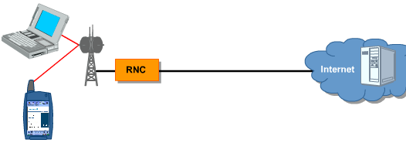
PS data transfer is IP-based. A message consisting of large quantities of data is divided into several packets. When these packets reach their destination, they are stored in data buffers and reassembled to form the original message. Consequently, the packet data transmission is carried out on an end-to-end basis, including the radio interface.
From an IP point-of-view, the WCDMA PS network can be divided into the following parts:
- The radio network, which can be regarded as a collection of all IP subnetworks used for the UE. A UE can be dedicated to CS communication, to PS communication, or be used for both. CS and PS services can be used simultaneously, depending on the capabilities of the UE and the radio networks.
- The PDN, which can be an Internet Service Provider (ISP) or a corporate network.
- The GPRS backbone network, which connects SGSNs and GGSNs.
- The Operation and Maintenance (O&M) network, which is the network for O&M systems.
- The service network, which is the network for hosts providing Internet services for the end-user, for example, public Domain Name System (DNS), e-mail, and WWW services.
These network parts are all interconnected by routers.

WCDMA System Functions & Operator Services

Supplementary Services
The Supplementary Services supported in WCDMA system are the following:
- Enhanced Multi-Level Precedence and Preemption (eMLPP)
- Call Forwarding Services
- Calling Line Indentification Services
- Connected Line Identification Services
- Call Waiting and Call Hold
- Closed User Group
- Multiparty Calls
- Advice of Charge
- Call Barring services
- Call Deflection
- Subaddressing (SUB)
- User-to-User Signaling 1 (UUS 1)
- Direct Dialling In (DDI)

WCDMA System Functions & Operator Services

Multimedia Messaging Service (MMS)
The Multimedia Messaging Service (MMS) makes it possible for mobile users to send multimedia messages from MMS enabled handsets to other mobile users with MMS-enabled handsets and to email users. It also makes it possible for mobile users to receive multimedia messages from other mobile users, email users, and from multimedia-enabled applications.
A multimedia messages consists of one or more media elements (text, picture, photo, video, animation, speech, audio, and so on). A multimedia messages can, for example, be a photo or picture post card annotated with text and/or an audio clip.
MMS represents the total solution, which consists of the MMS-enabled handsets, the Multimedia Messaging Center (MMC), plus possibly additional MMS applications, Multimedia Library (MML), Multimedia Processor (MMP) and Multimedia Client Proxy (MMCP).
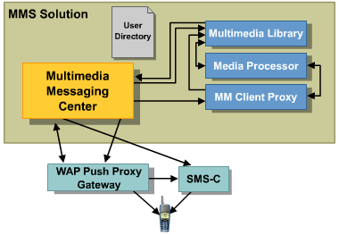

WCDMA System Functions & Operator Services

Multimedia Messaging Service (MMS)

MMC
The MMC implements the network side of MMS, as well as making it possible for an operator to offer MMS to its mobile subscribers.
The MMC can be deployed in any mobile network that supports WAP. The following figure shows an example of the MMC and its basic components, as connected within a mobile network for message traffic.
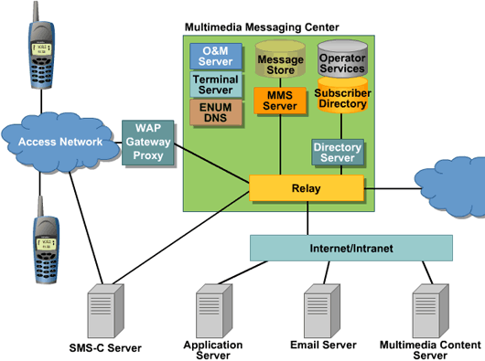
The different components of the MMC are described below.

Multimedia Messaging Center Relay
The MMC relay is the front-end of the MMC system. The relay provides an interface to the WAP Gateway/Proxy and various IP network connections/ protocols for message traffic. The relay also performs message routing. The MMS Relay component also has the responsibility to communicate with other operators MMS Relays via the standard MM4 interface.

Multimedia Messaging Service Server
The MMS server is the heart of the MMC. The MMS server provides the MMC processing engine and is responsible for the Store and Forward function of the MMC system.

Multimedia Messaging Center Directory Server
The MMC Directory Server provides access to the Operator Services Directory and a Subscriber Preferences Directory. The Operator Services and a Subscriber Preferences databases reside on the Multimedia Messaging Center Message Store.

Multimedia Messaging Center Operations and Maintenance Server
The MMC Operations and Maintenance (O&M) Server provides an interface into MMC management. The MMC Operation and Maintenance Server are responsible for the collection and preparation of system log files, event log files, statistics of the internal MMC nodes, alarm collection and delivery, billing data collection and preprocessing, and delivery to external nodes.

Multimedia Messaging Center Message Store
The MMC message store safely stores all the multimedia messages prior to delivering the message to the recipient.

Subscriber Directory (Subscriber Preferences)
The Subscriber Preferences Directory contains profiles of each of the subscribers. Subscriber profiles consist of information controlling the features and functionality of the multimedia messaging subscription. An interface to the database allows the operator and/or the subscriber to perform provisioning of the subscriber profile.

Operator Directory (Operator Services)
The Operator Services Directory contains profiles of each of the services. Operator Services subscription profiles consist of information controlling the features and functionality of the multimedia messaging subscription. An interface to the database allows the operator to perform provisioning of the Operator Services Directory.

MML
The MML provides a long-term repository, where multimedia messages and content may be stored for future use. The Multimedia Message Composer feature facilitates composing and submitting multimedia messages by WAP and web users without the need for a MMS-capable phone.
The long-term MML repository can be used by MMS users to store not only their multimedia messages, but also their pictures and images, audio, text, and video content. Multimedia messages can be forwarded to a user's personal storage area, the MMBox. Alternatively, content may be uploaded from a PC to the MML using the web interface. Content may be organized in different albums and can be used to create new multimedia messages. Subscribers can have both private and shared albums. A user can invite guests to visit shared albums. Private albums can only be accessed by the album owner.
Operators and content providers can store multimedia content within the MML for use by (sold to) subscribers. The operator may have selected content providers automatically to download multimedia content into the MML using a specific VASP interface. The user then accesses the MML through the web or WAP interfaces to browse for media content.

MMP
The MMP enables applications to send multimedia messages to any device, regardless of media format, screen colors, or size. It provides media processing and transcoding for purposes of media enhancement, as well as non-MMS-capable legacy terminal compatibility. Due to the fact that naive transcoding may result in unreadable content on the small screen of a mobile terminal, MMP enhances the image to correct such faults when the content type is identified.

MMCP
The MMCP provides the intelligence to determine whether a multimedia message is being sent to a non-MMS-capable mobile terminal. Furthermore, it will notify the recipient of a location from where the message can be retrieved. It provides the non-MMS-capable mobile terminal user with the ability to read multimedia messages via an Internet browser and/or WAP micro-browser.

WCDMA System Functions & Operator Services

Streamed Services
The Streaming Services is a function designed for the delivery of Digital Media Content using streaming, progressive download, and download. Streaming occurs when the content is consumed during the transport with a minimum of delay. The progressive download mechanism uses repetitive client HTTP GET request on parts of the target file. This enables consumption to start prior to the complete file being transferred. Consequently, progressive download offers a similar experience for the user as streaming, with the difference being a larger start-up delay. Download happens when the consumption of the content takes place after the complete file is downloaded.
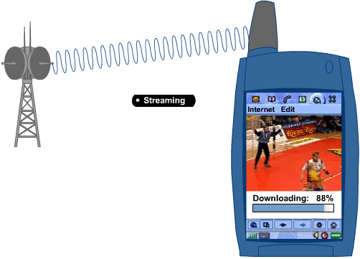
Digital Media, such as news, music, sport, and movies, encoded in 3GPP, MPEG-4, and Real Media formats are supported and can be transferred to mobile clients over service and core networks, as well as UMTS radio networks.
The Quality of Service (QoS) network bearer service and the streaming class is supported. This allows the operator to assign a fixed radio resource usage to each user and each session. In addition control mechanisms are present in the service and core network that secure the transport of the streamed content and keep interruptions to a minimum under unreliable conditions.
In addition access to streaming service is also supported through a circuit-switched bearer from 3G.324M mobile terminals through an interworking unit connecting to the streaming service.
The user scenario starts with the retrieval of a link to media content. This can be achieved using WAP/WEB, SMS/MMS, or other delivery methods. The next step is to attach to the content server with an HTTP request in order to retrieve the SDPnfile, which holds the information about the media file or stream. The information tells the streaming client in the UE how to retrieve the media. The client then initiates the QoS set-up in the radio and core network. When QoS is established, the client retrieves the media content from the content server.
Streamed Services application-related functions are contained in the Content on demand function, ECDS. It integrates the application administrative and operational functional areas, Multimedia Content Management, User Session Management, Streaming Server, Charging Management, and O&M.
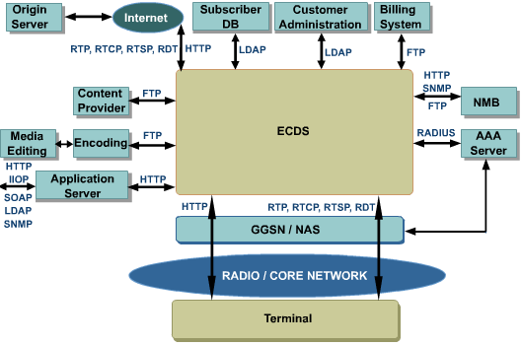

WCDMA System Functions & Operator Services

Streamed Services

Multimedia Content Management
The Multimedia Content Management function is part of the ECDS function. This function allows the operator to quickly and efficiently build, deploy, and maintain intranet sites. The integrated tools from Popwire and Real perform authoring and encoding, while adhering to 3GPP and Real formats. The upload of media function provides content upload using FTP, RFC 959 into individual workspaces, which can be reserved for different content providers. This functionality enables dynamic preparation of media content. The Storage function integrates a Storage Area Network (SAN).
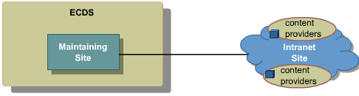
The SAN provides high volume storage capacity of raw data. Furthermore, the SAN enables storage resources to be treated and managed as a separate entity, allowing for a distributed and scalable architecture. The content rating function allows the individual content providers maintain pricing information for their content categories and streams, based on their agreement with the operator. This LDAP Directory Server database is partitioned, so that each content provider has only access to self-provided pricing data.

WCDMA System Functions & Operator Services

Streamed Services

User Session Management
Streamed Services function User Session Management is part of the ECDS function. When a user session is created, each IP address will be associated with a user request. If a user session does not exist and cannot be created, the user request is refused. User identification is achieved through IP address-MSISDN-resolution. When a user request arrives in the ECDS, the user is already authenticated by the GGSN/NAS. Moreover, the GGSN/NAS has transferred the parameter pair IP-address/MSISDN to the AAA server used on the Intranet. Subsequently, when the ECDS is to process this request, it is aware only of the temporary IP address assigned to the user's Mobile Terminal by the GGSN/NAS. In order to fully identify the user, the ECDS interrogates the external AAA server by means of the RADIUS Access Request message. The User Session Management component containing a RADIUS client communicates with the AAA server. The IP-address/MSISDN resolution is provided in the reply from the AAA server, assuming that access is granted.
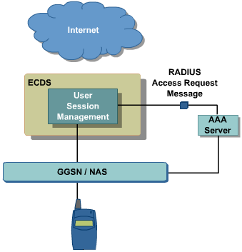
User-request authorization is realized by using URI (Uniform Resource Identifier)-access control. For this, the ECDS contacts the Subscriber Database that contains black- and white lists with URIs. Therefore, depending on the match, the user may or may not be allowed to view a particular URI.
User' subscribed Quality of Service is checked via reading in the subscriber database. Maximum subscribed bandwidth is checked.

WCDMA System Functions & Operator Services

Streamed Services

Streaming Server
Streamed Services function streaming server is part of the ECDS function. It stores and delivers media content. The delivery can be performed from the streaming server itself or through a proxy function allowing content to be retrieved from the outside of the operator domain. The streaming server supports the 3GPP standards, as well as media content of Real format. An operator may choose to provide 3GPP content, Real content, or both. Therefore, it supports both protocols and content formats of the 3GPP standards, as well as RealAudio® and RealVideo® content over the RealNetworks® Data Transport (RDT) protocol.
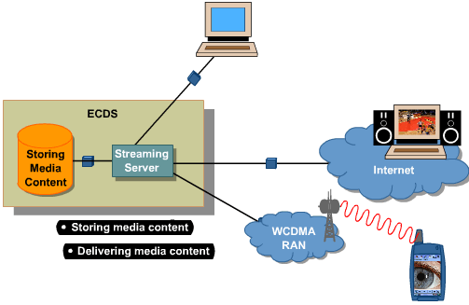

Charging Management
The charging management function for Streamed Services is controlled by the ECDS. It supports a standardized and configurable file-based charging in the form of periodically generated Charging Data Records (CDRs). It also supports postpaid charging, Hot Billing, and Real-Time charging over DIAMETER and PARLAY. Various events, such as abrupt termination, trigger the generation of charging data. Consequently, the charging module ensures that a user does not get charged for services that are not received.
The GGSN initially generates a Charging Identifier at set-up of the PDP context. If this is unavailable, the ECDS can generate a Charging ID. Also, the ECDS generates identifying tags to the sub sessions within the PDP context. This information allows partial records to be incorporated in CDR files, thus supporting a flexible payment model towards end-users and content providers. This feature can also be used to make sure a user is not charged for data volume or airtime when premium services are accessed.
In case of a failure in CDR generation, the ECDS can be configured to either continue without charging or to refuse all new connections until the error condition is cleared. Loss of connection to the billing system can be notified by a log file entry in the O&M system.

Operation & Maintenance
Streamed Services function O&M is part of the ECDS function. It provides functionality for Fault Management (alarms and fault logging), Performance Management (logging), Configuration Management, Management (provisioning of pricing data), Statistics and Logging, Installation, Start and Stop, Restart, and Backup and Recovery.

Streaming Client
Streamed Services is designed for terminals supporting transparent end-to-end Packet-Switched Service (PSS), 3GPP 26.233, 26.234. Streamed Services does not include terminals.

WCDMA System Functions & Operator Services

Videotelephony
The 3G videotelephony function enables end-to-end multimedia communication over the circuit-switched domain in the WCDMA network.
The standard for videotelephony over 3G networks has been set by 3GPP in release 99 and is called 3G.324M. This standard is based on the ITU-T H.324 standard and describes how 3G.324M multimedia services can be implemented in the WCDMA circuit-switched domain with interworking with the IP domain through H.323/SIP. The figure below outlines the reference architecture for 3G videotelephony.
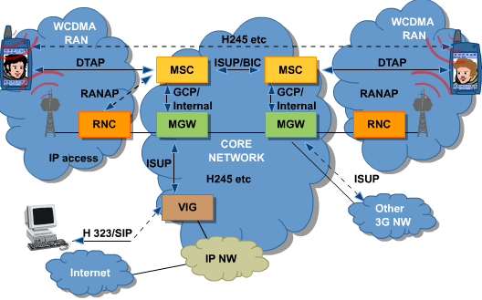

Call Set-Up
When setting up a 3G videotelephony call a transparent 64K kbps circuit-switched bearer has to be first set up on the air interface and through the core network and then on the B-terminals air interface, in the case of the mobile-to-mobile call. In the case of interworking with another network, typically Internet, the 64 kbps circuit-switched bearer is set up to the video gateway system ViG. The setup of the video communication is subsequently done end-to-end using in-band signaling between the two terminals or between a terminal and the ViG using the H.245 protocol according to the 3G.324M standard.
During call setup the terminal will send information in the setup message in DTAP indicating that a 64kbps circuit-switched bearer for unrestricted digital information (UDI) is to be established. It will also be indicated that it is a video telephony call, which will use H.245/H.223 signalling. As a result, the core network is able to charge the call accordingly, and in case of interworking with other networks, also can connect the ViG. It should be noted that this low layer information in the setup message from the terminal will be transparently sent through the core network towards the B-terminal, in order for both sides to understand that this will be a video call. Further information and call setup will be achieved through in-band signalling.

Requirements on Radio Access Network
In the WCDMA Radio Access Network the conversational Radio Access Bearer (RAB) for 64 kbps multimedia is required for videotelephony. This is a transparent conversational RAB for 64 kbps multimedia to the circuit-switched core network domain.

Requirements on Core Network
In the WCDMA Core Network the multimedia functionality using UDI 64 kbps synchronous transparent bearer supports the following call cases:
- Multimedia calls between WCDMA subscribers
- Multimedia calls between WCDMA and NetMeeting/XP Messenger subscribers. (This call case requires the ViG.)
WCDMA handovers to/from GSM are not supported for multimedia calls.

WCDMA System Functions & Operator Services

Videotelephony

Interworking with IP networks via ViG
The Video Gateway System (ViG) comprises a fully featured network that allows for video call scenarios between 3G.324M mobile terminals and H.323/SIP terminals over an IP network.
The 3G.324M mobile terminal accesses the ViG network through a 64kbps Circuit-Switched Data connection in the 3G mobile network, indicating that a multimedia service is requested. After call setup the media streams will be sent directly between the clients and the MGW.
Subscribers to the ViG system are associated in the network with two unique identifiers that can be used for user identification and call routing. They are, as follows:
- A ViG user name (H.323 ID), with the format of an e-mail address (mandatory)
- A personal E.164 telephone number (optional)
The routing of calls between 3G.324M mobile terminals and H.323/SIP terminals will be carried out in the core network. Roaming call cases can, therefore, be supported by configuring routing data in the core network, provided that the ViG is accessed using a public number (E.164).

Service Network
The HLR provides the administrative means to provide mobile subscribers with the appropriate basic service (Synchronous General Bearer Service - BS30) to handle multimedia calls.

Charging
In the 3G Video Telephony function both pre-paid and post-paid charging is supported. The MSC and the ViG will generated the necessary charging information for a multimedia call.
The Charging Data Record (CDR) will contain an indication of whether it is a multimedia call or not. Based on this information, it is possible to apply different tariffs for 3G videotelephony.

WCDMA System Functions & Operator Services

Browsing
Browsing enables a user to access applications and services on the Internet, Mobile Internet, and corporate intranet using standard browsers, which support a variety of mark-up languages.
The browsing system function is based on the Mobile Internet Enabling Proxy (MIEP). As well as incorporating the functionality of a WAP gateway, MIEP serves as the bridge between the mobile network and the applications and services. MIEP can be seamlessly integrated with the core network.
The Browsing system function in WCDMA is implemented by the Ericsson MIEP.
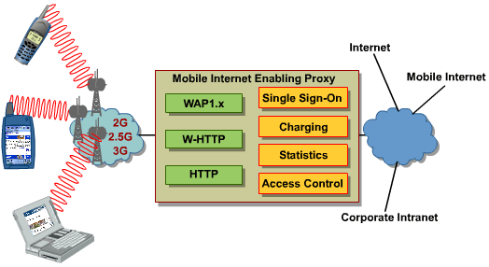
MIEP offers the following types of functionality:
- The implementation of Mobile Internet services through better usability and operator control. In addition to basic Pull and Push functionality, features, such as Single Sign-On (SSO) of end-users, user information forwarding, user friendly error messages, and auto provisioning are offered.
- The ability to process content that is independent from the content type, resulting in support for all mark-up languages. Therefore, a wide range of content can be downloaded to the user's mobile device.
- The availability of multiple protocol stacks, making it possible for users to access services with a wide range of devices.
- The ability of operators to control user and service access, gather extensive statistics, and collect different types of charging data.
- Encrypted User Information Forwarding, which enables the user to access, for example, location-based services and push services without revealing their identity.

WCDMA System Functions & Operator Services

Location-Based Services
The Location-Based Services (LBS) function is based on Ericsson's Mobile Positioning System (MPS), a commercially proven concept that delivers the location co-ordinates of handsets. The position can be used to provide mobile subscribers with information and services that take advantage of their given geographical location. LBS works with all WCDMA handsets, enabling mobile operators to reach a mass market immediately.
In addition to MPS, LBS includes content and application middleware, as well as a range of professional services to ensure that location-based services can be quickly and smoothly integrated into the operator's mobile network. MPS supports WCDMA (MPS-U).
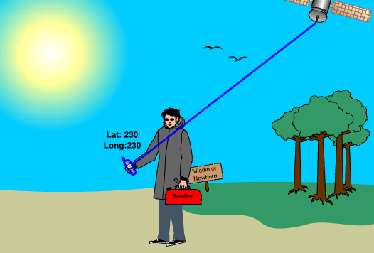
MPS-U consists of the Gateway Mobile Positioning Center (GMPC) and network features in the form of software extensions for the MSC/VLR, HLR, and RNC. The GMPC is the Ericsson implementation of the standardized node Gateway Mobile Location Centre (GMLC). MPS-U delivers the position of the subscriber to the applications, referred to as LoCation Service Clients (LCS Clients). The position co-ordinates are then used by LCS clients, which are provided either by the operator or by service providers on the Internet.
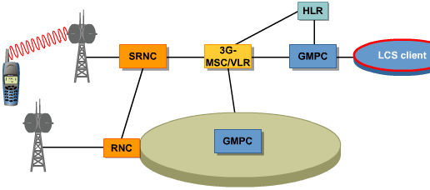
The LCS client is not a part of the MPS, but rather a part of the LBS solution. The LCS Client contains applications that make use of the positioning information. It communicates with the GMPC through a standardized Application Programming Interface (API), that is, the Mobile Location Protocol (MLP) protocol according to Open Mobile Alliance (OMA). The standardized API makes it easy for third party application developers to build new services. MLP positioning requests from the LCS client to the GMPC and positioning answers from the GMPC to the LCS client are exchanged. The GMPC can handle connections from multiple LCS clients simultaneously.
In order to support different accuracy demands, a number of positioning methods have been standardized, both for GSM and for WCDMA. The only method supported in 2003 for WCDMA is the Cell-Id positioning method.

Privacy and Roaming
In order to protect the end-user privacy, 3GPP has standardized a wide set of possibilities . MPS supports these standards. The possibility to position users while roaming is also supported, according to standards.

LBS Evolution and Migration GSM-WCDMA
LBS Evolution and Migration GSM-WCDMA MPS has the same GMPC (and API) for both GSM and WCDMA. The API is the protocol between the GMPC and the application or application middleware. It is possible to run the previous releases of the API in parallel with the new, so that two versions of the API run simultaneously.

WCDMA System Functions & Operator Services

IN Services
The Intelligent Network (IN) is a key element in the Service Network Architecture. It provides the means to introduce innovative and competitive telecom services in a cost-effective way with a short lead-time. The following are examples of available services for WCDMA:
- The Virtual Private Network (VPN) service provides the corporate customer with a private numbering plan for fixed and mobile end-users within the public telephone network.
- The Information & Business (I&B) service can operate as one or more of three services: Free phone, Premium Rate and Universal Access Number.
- The Intelligent Router & Data Server (IR&DS) is a framework containing several IN regulatory services including, for example, Route selector, Access screening, and Number Portability.
Number portability means that the end user can keep the same telephone number when changing from one Service Provider to another.
The Intelligent Network is an architecture where call control logic is separated from the switches into a centralized node (the Service Control Point [SCP]) that communicates with the switching platform (the Service Switching Point [SSP]) using a service-independent protocol (for instance, CS1, CS1+, CAMEL). Service data is contained on the Service Data Point (SDP) and management of the IN services is done through the Service Management System (SMAS). The Intelligent Peripherals (IP) or IVRs are the nodes or devices that perform the Specialized Resource Function (SRF) within the IN architecture.
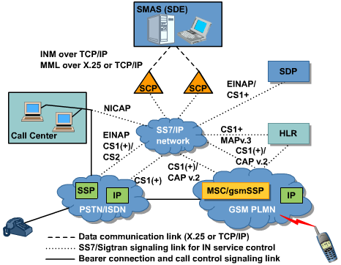
The signaling towards the SCP from the other IN nodes can either run over a classical SS7 network or using SIGTRAN.

WCDMA System Functions & Operator Services

IN Services

SCP
The Service Control Point (SCP), which holds the SCP function (SCF), is the heart of the Intelligent Network where every IN call asks the SCP for instructions on how to execute the IN service. In WCDMA two different implementations of the SCP are supported, AXE based (SCP) and TSP based (INS).
The AXE SCP supports co-location with Ericsson's AUC, FNR, HLR, and MSC products. Special consideration is needed if gsmSSF and gsmSCF are to be located in one physical node when using CAMEL.
The TSP-based INS middleware offers an open Customer Administration Interface (CAI) towards the customer administration system. The INS also supports generation of Call Data Records (CDR) directly from the SCP. It also supports an interface to allow services to retrieve and update call rating data (prepaid account data) stored in the Rating Engine (RE).

SSP
The Service Switching Point (SSP) executes tasks for the SCP. Its main functions are to switch IN calls through the network, play recorded announcements, trigger and invoke IN calls, generate charging details and very important control of network congestion. The SSP function (SSF) is part of the MSC/VLR (gsmSSF) and the SGSN (gprsSSF). The MSC/VLR also supports the Specialized Resource Function (gsmSRF), which is used to order the announcement machine to play announcements.

SDP
The most important task for the Service Data Point (SDP) is to provide the Intelligent Network with high capacity data storage with full data integrity, and is accessible via a well-defined interface. It interfaces the SCP over SS7 and the SMAS system via a Binary interface (BIF) over TCP/IP.

SMAS
The Service Management System (SMAS) is Ericsson's product for installing, provisioning, and managing IN services towards the AXE-based SCP. SMA Base is a set of tools and applications that give service providers a common platform for service provisioning and end user control of IN services.

SDE
The Service Development Environment (SDE) is an application for developing IN services for the AXE SCP.

SDK
The Service Development Kit (SDK) allows operators to develop their own services with the IN capabilities offered by the INS and TSP platform.
Principles for service development for the Ericsson Intelligent Network Server (INS) are based on Openness, Industry Standards, and Reuse of software components.
Openness means that operators can easily develop their own service logic to execute on the INS. Industry standards such as the Rational Unified Process (RUP) for software engineering process support, the Unified Modeling Language (UML) for Visual Modeling, and the Java programming language for implementation are used for service development.
Service development is performed outside the actual INS node, on standard computer hardware and software platforms. After the service logic has been developed, it can be deployed onto the INS target node.

WCDMA System Functions & Operator Services

Single Sign On (SSO)
Single Sign On (SSO) allows users to access content from various sources and content providers without making a manual authentication and authorization each time. If the user, for example, wants to retrieve a multi-media message or watch a football clip, the network will take care of authentication and authorization.
The SSO solution depends on the business model of the operator. Several business models are developed the most important are the Walled Garden SSO and the HE-VASP SSO (Home Environment Value Added Service Provider ).
On the Internet, a Walled Garden refers to a browsing environment that controls the information and Web sites the user is able to access. This is a popular method used by ISPs in order to keep the user navigating only specific areas of the Web, whether for the purpose of shielding users from information -- such as restricting children's access to pornography -- or directing users to paid content that the ISP supports.
In the Walled Garden SSO business model, the operator provides all services. An end-user can then use SSO for the services within the walled garden for which the user has a subscription and for which the operator has activated the service.
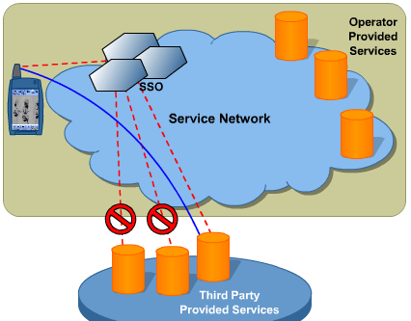
In the HE-VASP (Home Environment-Value Added Service Provider) business model, the operator also handles the delivery of services (authorization and a bit-pipe) that belong to an external service provider. An end-user can then use SSO for the services within the walled-garden and for services offered by a third-party service provider that has a business agreement with the operator.
The SSO Infrastructure consists of the nodes AAA, HTTP Proxy, and MIEP, and also an SSO SDK.

Introduction

Lesson Objectives
Upon completion of this lesson the student will be able to:
- Describe the interfaces and the corresponding protocols in WCDMA network

WCDMA Main Interfaces and Signaling Protocols

WCDMA RAN Interfaces:
- Uu interface
- Iu interface
- Mub interface
- Mur interface

Circuit-Switched Interfaces:
- Iu CS interface
- C interface
- D interface
- F interface
- CAMEL interface
- Mp interface

Packet-Switched Interfaces:
- Iu PS interface
- Ge interface
- Gi interface
- Gr interface
- Gp interface
- Gom interface

Application Enablers Interfaces
- Lg interface
- Lh interface

WCDMA Main Interfaces and Signaling Protocols

WCDMA RAN Interfaces

Uu interface
Uu is the radio interface between the UE and the WCDMA RAN.
The interface is specified in the 24- and 25-series of the 3GPP Technical Specifications.

Iu interface
The Iu interface is the interface between the WCDMA RAN and Core Network (Circuit-Switched and Packet-Switched) and is divided into two parts, Iu-PS for handling packet data connections and Iu-CS for handling circuit-switched connections.
For a further description, see the interface chapters for Circuit-Switched and Packet-Switched.

Mub interface
The Mub interface is the O&M Machine interfaces for the RBS (Node B) in the WCDMA RAN.

Mur interface
The Mur interface is the O&M Machine interfaces for the RNC in the WCDMA RAN.

WCDMA Main Interfaces and Signaling Protocols

Circuit-Switched Interfaces

Iu CS interface
The WCDMA RAN - Circuit-Switched interface is used to carry the user plane (user data as speech and CS data) and control plane (signalling as information concerning WCDMA RAN management, call handling, and mobility management).
The interface is specified in the 25.41x-series of the 3GPP Technical Specifications.
In a layered architecture, the Media Gateway manipulates and transports the user plane part of the Iu interface. The control plane part of Iu is relayed to the appropriate MSC (which acts as the Media Gateway Controller).

C interface
In the Circuit-Switched (GMSC) - Authentication, User Databases, and Provisioning (HLR) interface, the MAP protocol is used to perform the interrogation needed to set up calls to a mobile subscriber. To forward a short message to a mobile, the Circuit Services interrogates the User Databases to obtain routing information.
Signaling on this interface uses the Mobile Application Part (MAP), which, in turn, uses the services of Transaction Capabilities. See TS 29.002.

D interface
On the Circuit-Switched (VLR) - Authentication, User Databases and Provisioning (HLR) interface, the MAP protocol is used to exchange data related to the location of the mobile station and to the service management of the subscriber.
Signalling on this interface uses the Mobile Application Part (MAP), which, in turn, uses the services of Transaction Capabilities. See TS 29.002.

F interface
On the Circuit-Switched (MSC) - Authentication, User Databases and Provisioning (EIR) interface, the MAP protocol is used to exchange data, in order that to verify the status of the IMEI retrieved from the Mobile Station.
Signaling on this interfaces uses the Mobile Application Part (MAP), which in turn uses the services of Transaction Capabilities. See TS 29.002.

CAMEL interface
CAMEL (Customised Applications for Mobile network Enhanced Logic) provides the mechanisms to support operator-specific services that are not covered by the standardised GSM services and also when roaming outside the HPLMN by using Intelligent Network (IN) principles.
The CAMEL-specific interfaces are detailed in 23.078.

Mp interface
Inter-working with the PSTN network is achieved by TTC ISUP, standard ETSI TUP+ and market variants such as SSUTR2 and CAS R1 signalling. ISDN inter-working is supported via ETSI PRA and BRA.

WCDMA Main Interfaces and Signaling Protocols

Packet-Switched Interfaces

Iu PS interface
The WCDMA RAN - Packet-Switched interface is used to carry the user plane (user data) and control plane (signalling as information concerning mobility management, session management, and packet data transmission).
The Iu_PS interface is defined in the 3GPP TS 25.41x-.

Ge interface
The Ge Interface is the logical interface between the SGSN in Packet-Switched and the SCP in Application Enablers for real-time support of a users activity in the network. In other words, it allows the SCP to control how and if the Mobile Station may connect to the network, as well as its network resource usage. One example of SCP control is the prepaid functionality.
Signalling on this interface uses the Mobile Application Part (MAP), which, in turn, uses the services of Transaction Capabilities (TCAP). See TS 29.002.

Gi interface
This interface connects the PLMN to external public or private packet data networks. The Gi interface is used for GGSN control signalling towards ISP servers located in IP networks, such as the ISP network. The Gi interface is also used for transportation of all end user IP data between the mobile network and external IP networks.
The Gi interface is defined in the 3GPP TS 29.061.

Gr interface
The Gr interface is the Packet-Switched (SGSN) interface towards the Authentication, User Databases, and Provisioning (HLR). The interface is used for storage/retrieval of subscriber data. It is also used to update the HLR of the location information of the MS.
Signaling on this interface uses MAP, which, in turn, uses the services of Transaction Capabilities (TCAP). See TS 29.002.

Gp interface
The Gp interface is used between Packet Services located in different mobile networks, allowing visiting subscribers to be routed through their home network. Signaling on this interface uses the User Datagram Protocol (UDP/IP). The Gp interface is defined in TS 29.060.

Gom interface
The Gom interface connects O&M equipment to the Packet-Switched network, making it possible for an operator to communicate with the Packet-Switched.
The Gom interface is Ericsson-specific, and it is not part of the GPRS standard.

WCDMA Main Interfaces and Signaling Protocols

Application Enablers Interfaces

Lg interface
The Lg interface is used between the Location Services, within Application Enablers, and the Circuit-Switched. This interface is used by the Location Services to convey a location request to a particular UE/MS. The location results is returned to the Location Services.
The Lg interface is an Ericsson proprietary interface.

Lh interface
Interface between the Location Services, within Application Enablers, and the HLR within Authentication, User Databases, and Provisioning. This interface is used by the Location Services to retrieve the address of the visited MSC or SGSN for a particular target UE/MS, whose location has been requested.
The Lh interface is an Ericsson proprietary interface.

